Installation Guide for AtlHealth



September 2020

Table of Contents

1. Introduction 7

1.1. Purpose [3] 7

2. Installation Manual 7

2.1. Pre-requisites [3] 7

2.2. Pre-installation Tasks [3] 8

2.3. Installation Procedure [3] 8

2.3.1. Database [3] 8

2.3.2. Practical Project [3] 9

2.4. Backup and Recovery of the Practical Project and Database [3] 10

2.5. Contact Information [1] 14

# 

# Introduction

## Purpose [3]

The purpose of this Installation guide is to show and describe in technical terms, all the steps necessary to install this software product and to make it operational. This installation manual will explain in detail what software products are required and what pre requisites needs to be in place and checked. The manual will also explain in detail how any end user can install the software application directly from the CD or Shared Drive

# Installation Manual

## Pre-requisites [3]

The following pre-requisites must be fulfilled before that installation of the actual application can begin

**Pre-requisites:**

* 32 bit or 64 bit Microsoft Windows XP or higher
* Microsoft .Net Framework 4.7
* Microsoft SQL Express
* Microsoft Office 2010 or higher (MS Excel and MS Word)
* An Active Email Account
* CD-Rom Drive
* Connection to the internet

The application is a Microsoft Windows Application and will be installed in the Users Local Computer. The application is installed directly from a CD with an installation file. There are no other configuration files needed and the installation should install a workable application.

## Pre-installation Tasks [3]

The client PC needs to be checked if all pre-requisites software and hardware is availible

The system adminitrator needs to create the SQL Database needs to be created and all tables generated.

All Data needs to be migrated successfully and tested with SQL Scripts to check data quality

## 

## Installation Procedure [3]

* Check all pre-requisites. Install any missing requirements.
* Create the database for AltHealth
* Create the tables for the AltHealth Database
* Perform Data Migration by importing all data into the newly created database.
* Install application from CD
* Configure email account on Application

### Database [3]

* First, download the setup package of free edition of SQL Server Express from the Microsoft website on the clients PC
* After download, click on the installation file and open.
* Select the required installation type of SQL Server Express Edition. The Basic Edition will be enough for this purposes
* The Download will start. Once finished, you can start to install the SQL Express edition on client’s PC
* Follow the onscreen instructions and accept the licence agreement.
* In the database Engine configuration, choose the Windows Authentication Mode
* Also choose the default directories and backup locations of the database.
* Continue with the installation by following the on screen prompts and wait for the installation to be completed.
* After installation, test the connection
* The database application is installed and ready for creating the database and import the data.

### Practical Project [3]

Installation of the AltHealth System can be done in 3 easy steps with ClickOnce. ClickOnce is a feature that will also do some pre requisite checks to ensure that the application can be supported.

Step 1: Insert the CD into the CD ROM Drive

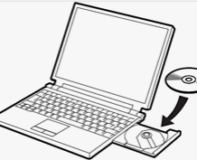

Step 2: Open the Folder and double click on Setup

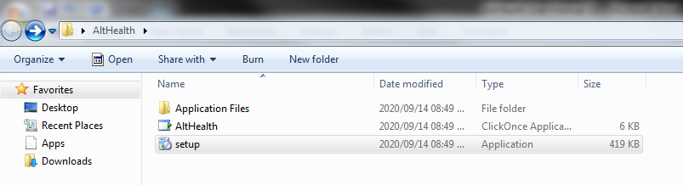

Step 3:

Select Install to install the application

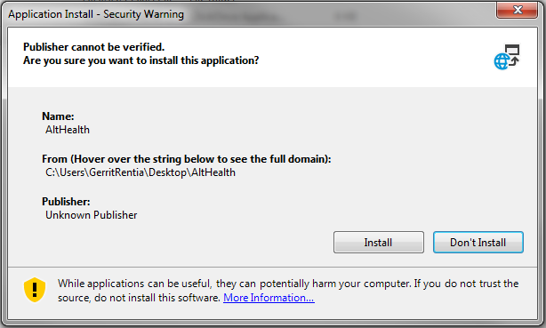

The application can be found under your start menu in Windows

## Backup and Recovery of the Practical Project and Database [3]

Backups:

* An automated background process ensures the backup of the databse to a specific location by means of scheduling.
* Full backups will be scheduled to run on a daily basis.
* Backups will be made on the client local PC and the AltHealth application will allow the client to recover the data without the need of any administrator.

Recovery Procedure:

* The latest backup will be stored on the clients local PC every day
* If the client sees any data anonomolies, or corrupt data, and wants to restore to the previous days version of the database and data, the System Administration section of the application, gives the client the option to recover the data to the latest stored version with only a few easy steps
* The below screenshots explains how the data can be recovered:

Step 1:

Select System Administration

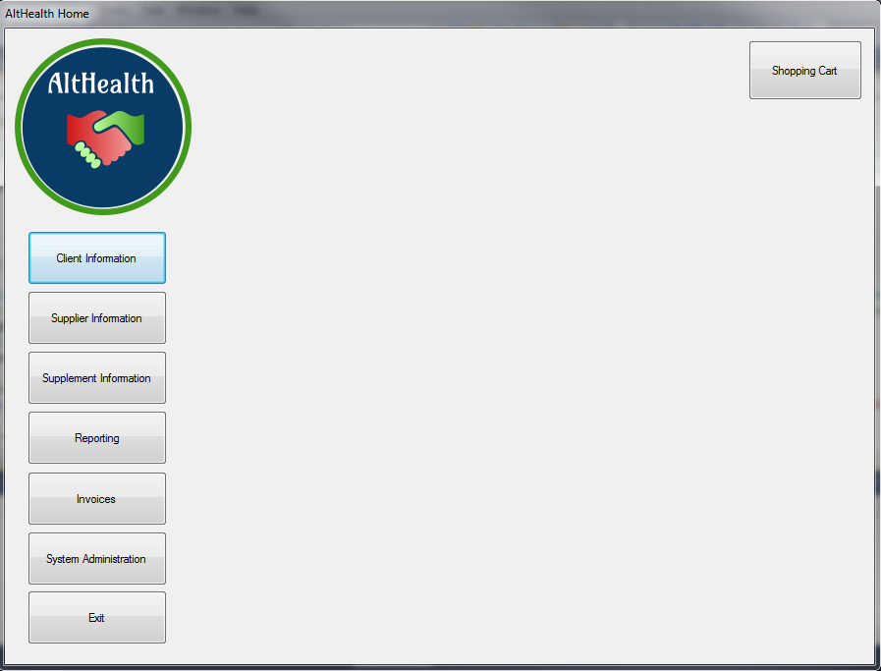

Step 2:

Select “Recover Database”

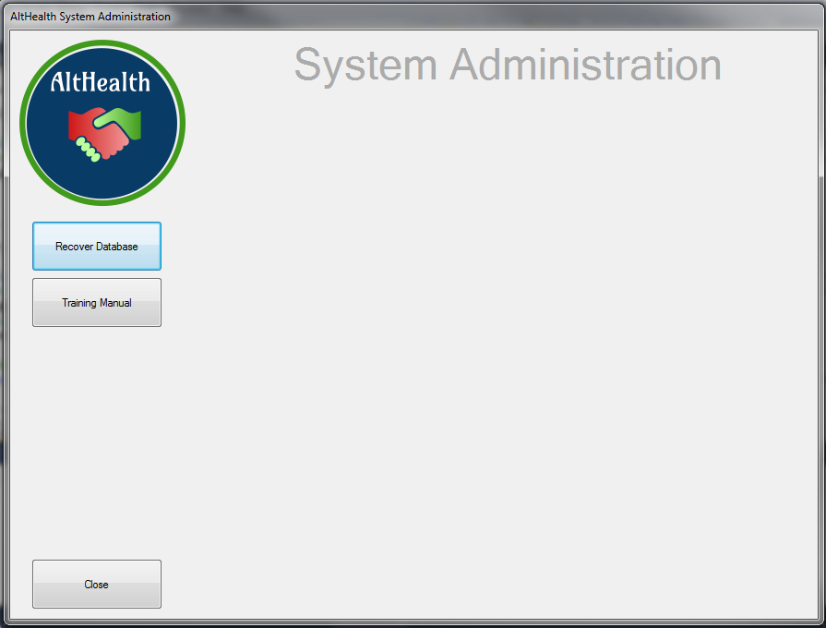

Step 3:

## Confirm and wait for the confirmation message. The database will be restored to the latest version.

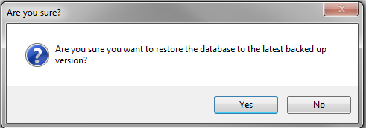

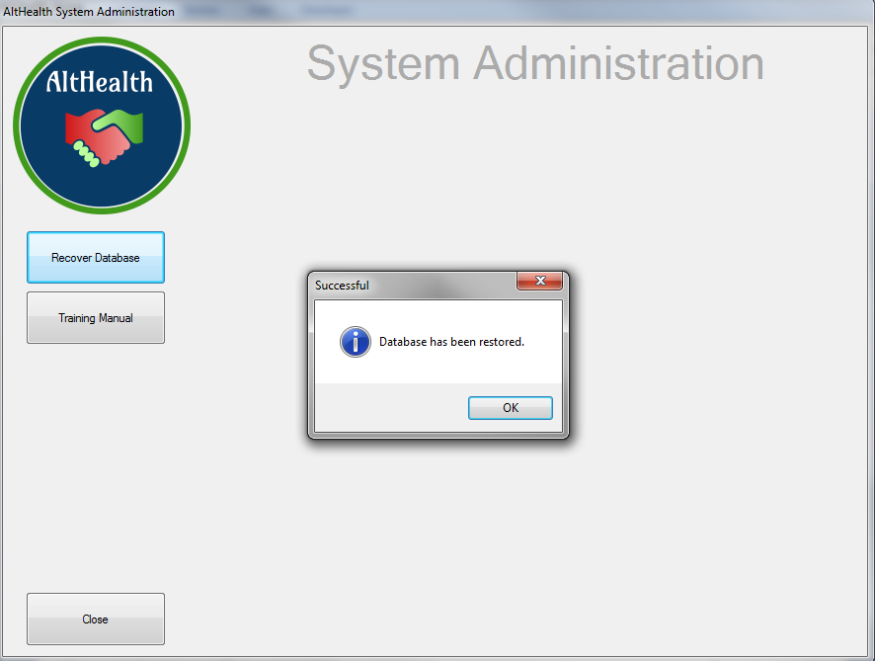

## 

## Contact Information [1]

|  |  |
| --- | --- |
| Software designer / developer | |
| Name | Gerrit |
| Surname | Van Niekerk |
| Contact number | 0825319681 |
| E-mail address | 61639303@mylife.unisa.ac.za |

User Guide for AltHealth



September 2020

Document Revisions

|  |  |  |
| --- | --- | --- |
| Date | Version Number | Document Changes |
| 14/09/2020 | 0.1 | Initial Draft |
| 21/09/2020 | 1.0 | Final Version |
|  |  |  |
|  |  |  |
|  |  |  |
|  |  |  |
|  |  |  |
|  |  |  |
|  |  |  |

Table of Contents

Contents

1. Introduction 20

1.1. Scope and Purpose [5] 20

2. Quick Start Guide [5] 20

3. Client information 22

3.1. Client Information – View Client Details 22

3.2. Client Information – Edit Client Details 25

3.3. Client Information – Add New Client Details 31

3.4. Client Information – Export Client Information 35

4. Supplier Information 39

4.1. Supplier Information – View Supplier Details 39

4.2. Supplier Information – Edit Supplier Details 42

4.3. Supplier Information – Add New Supplier Details 48

4.4. Supplier Information – Export Supplier Information 52

5. Supplement Information 56

5.1. Supplement Information – View Supplement Details 56

5.2. Supplement Information – Edit Supplement Details 59

5.3. Supplement Information – Add New Supplement Details 65

5.4. Supplement Information – Export Supplement Information 69

6. Reporting 73

7. Invoices 75

7.1. Creating an Invoice – Shopping Cart 75

7.2. Search for Existing Invoices 86

8. Restore data to the latest version 91

9. Appendices 94

9.1. Appendix A – Change Request Template 94

9.2. Appendix B – Information Flow Diagram 96

# 

## Introduction

## Scope and Purpose [5]

AltHealth is an application developed specifically for the business of Mr John M, a health care provider. The application was developed according to the needs of Mr John M.

This windows application gives Mr John M the ability to smooth his business operations and have the appliction do esactly as he required.

Hihglevel Key features and benefits of the application:

* Central Customer database with ability to add new clients and maintain existing clients
* Add and maintain supplements and the stock levels
* Add and maintain suppliers
* MIS Reporting tool to help Mr John M make informed decisions to run his business
* A Shopping cart to create invoices
* Invoice retrieval
* Self-Database recovery functionality

The purpose of this user guide is to provide a step by step overview of how to perform tasks in the system. The guide will in detail, explain each and every step that can be performed in the system

## Quick Start Guide [5]

Once the application is launched, the home page will appear. The application home page will give the user the ability to jump between sections and serves as the core of the application.

Each section is explained below:

**Client Information** – This section allows the user to view all clients, export the list of clients, add new clients and edit existing clients

**Supplier Information** - This section allows the user to view all suppliers, export the list of suppliers, add new suppliers and edit existing suppliers

**Supplement Information** – This section allows the user to view all Supplements, export the list of supplements, add new suppliements, edit existing supplements, add additional stock

**Reporting** – This section has 6 reports for the client to view

**Invoice**  - This section allows the user to retrieve and email exiting invoices.

**System Administration** – This section allows the user to maintain the email account, do database recovery and download a copy of this training manual

**Shopping Cart** – This section allows the user to create a new invoice from scratch

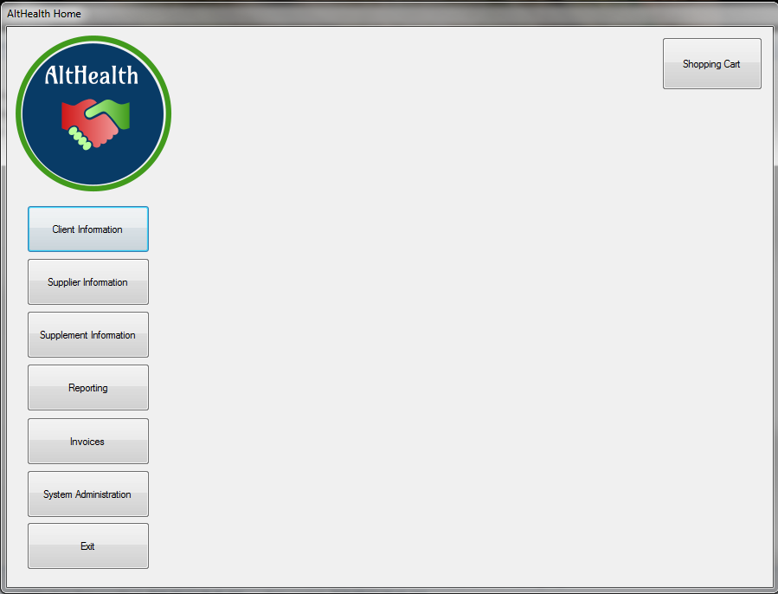

## Client information

## Client Information – View Client Details

Click Client Information

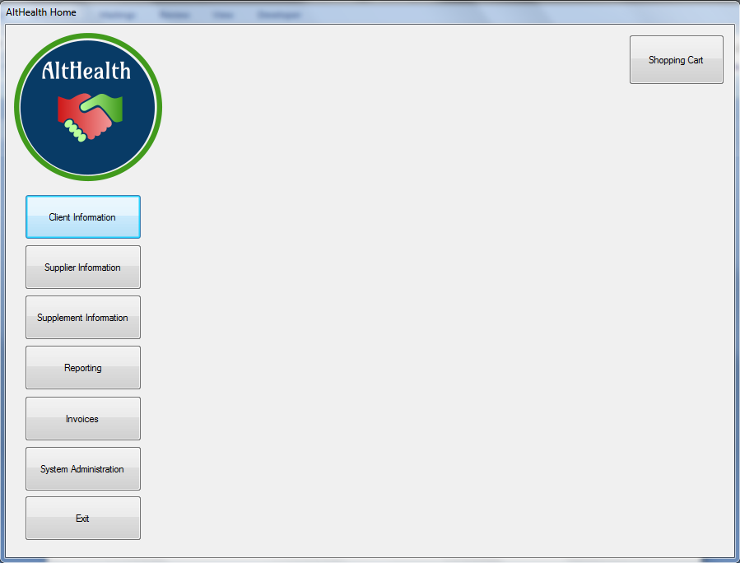

A List with all clients in the database will be displayed.

Use the scroll bar on the right to browse through the list.

The headings in the table can be used to sort the data

To view a particular client, double click the record

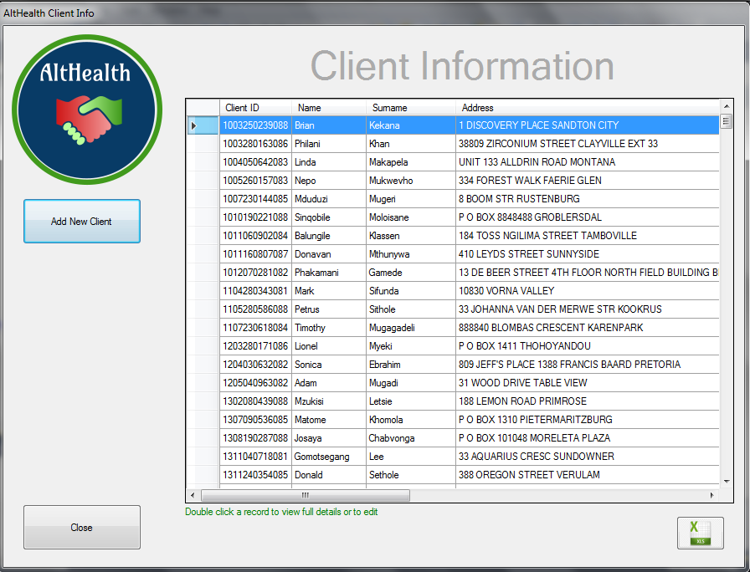

The client information will be displayed

To move back to the Client Information Screen, click the Close Button

To Edit the record, Click on the Edit Button

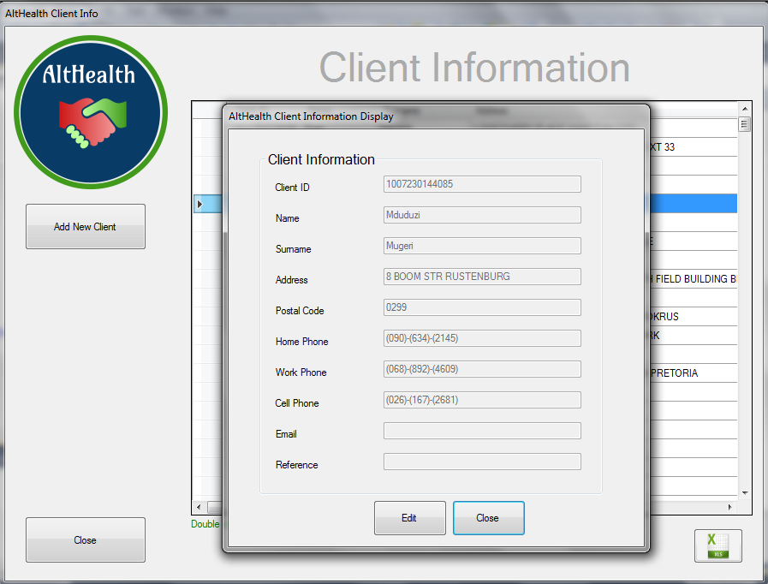

## 

## Client Information – Edit Client Details

To Edit a client, search for the client and double click on the name. Click the Edit Button

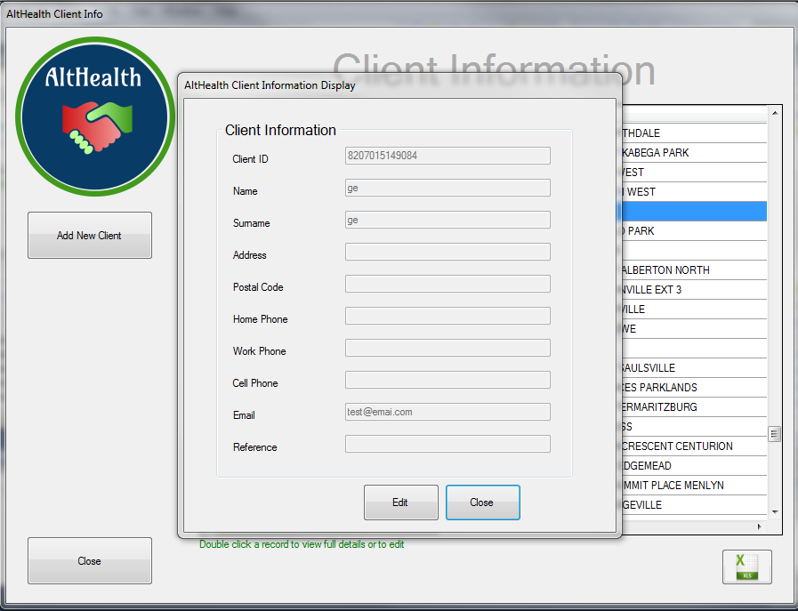

Certain field will now be editble on the screen. It is not allowed to edit certain information on a client like the ID Nr

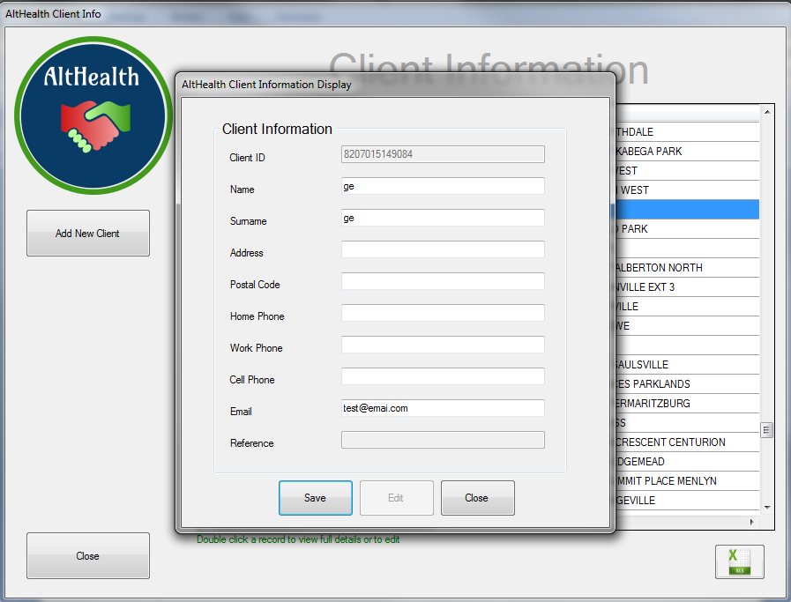

Edit the needed details and click the save button

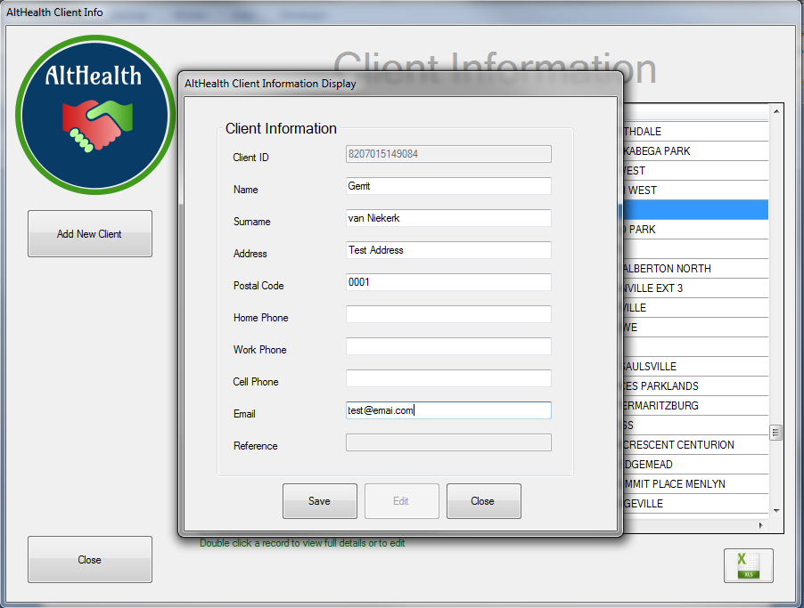

Confirm the message

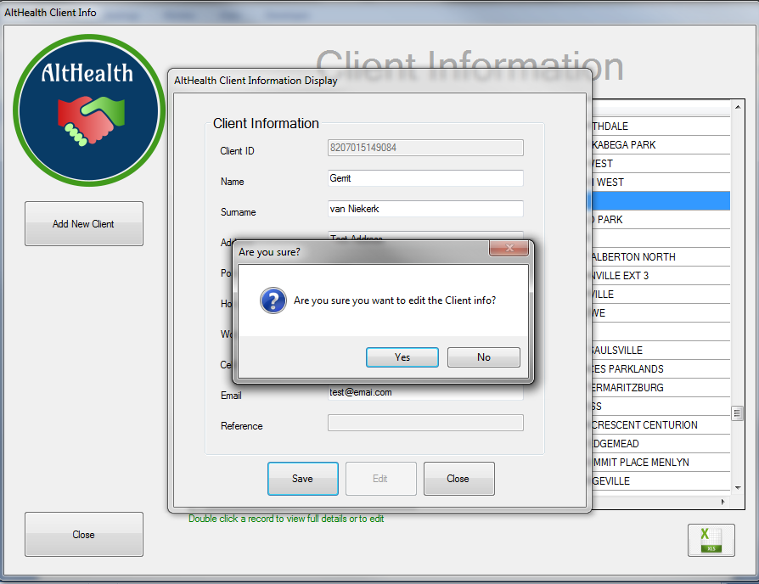

Wait for the confirmtion and review the changes in the list

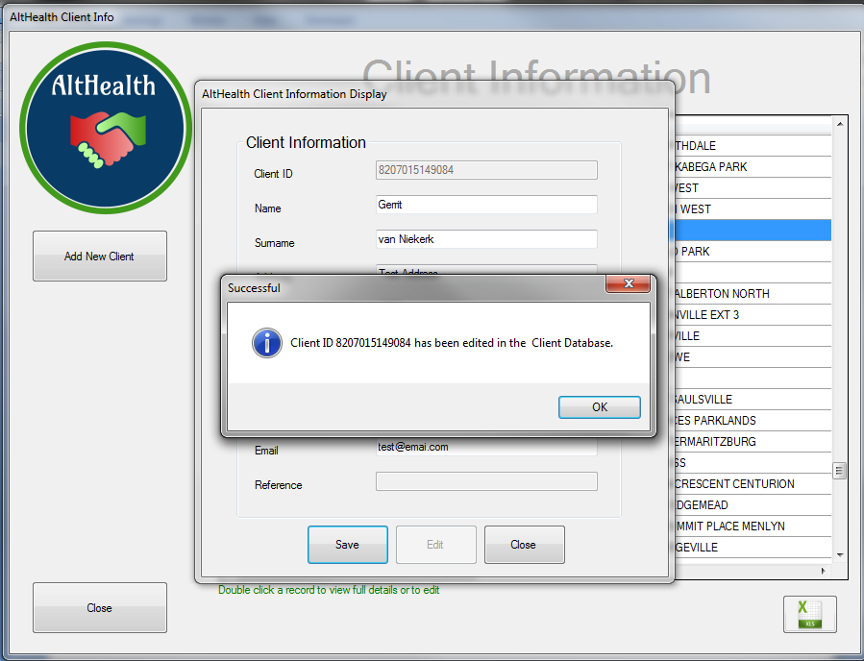

Changes made in the database

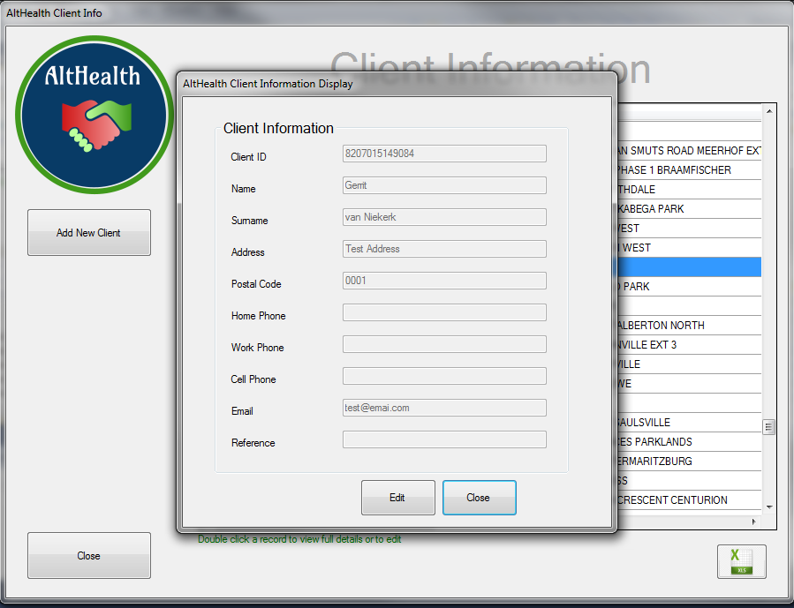

## 

## Client Information – Add New Client Details

To add a new client, click on the Add New Client Button



To Sve the Customer Record to the Database, fill in all Mandatory Fields and Click the OK Button

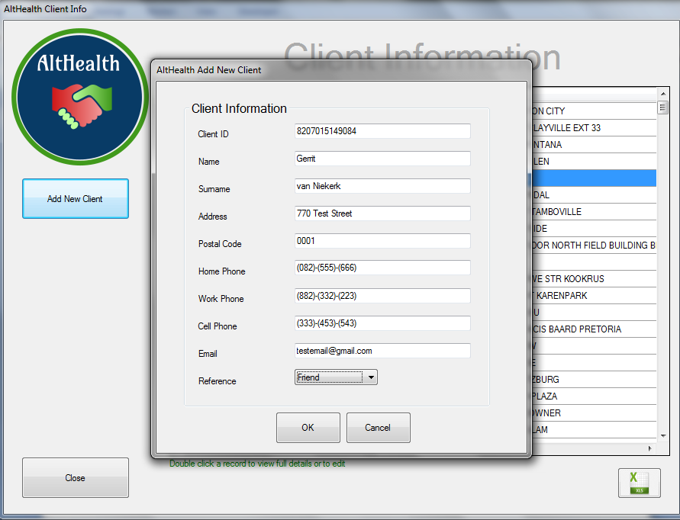

Confirm the addition by Clicking the YES Button

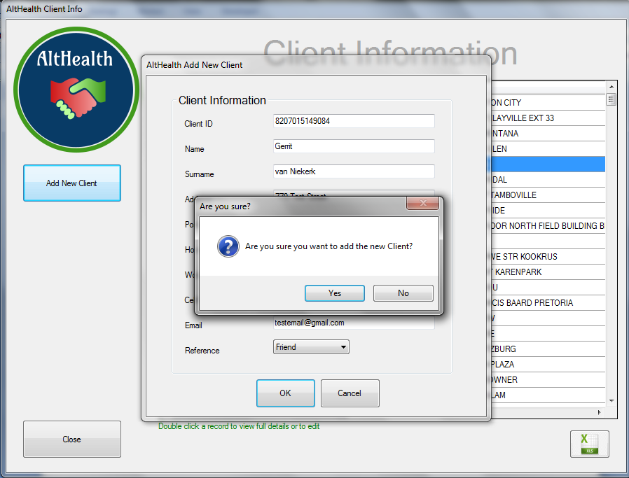The confirmation message is displayed informing the user that the client has been added

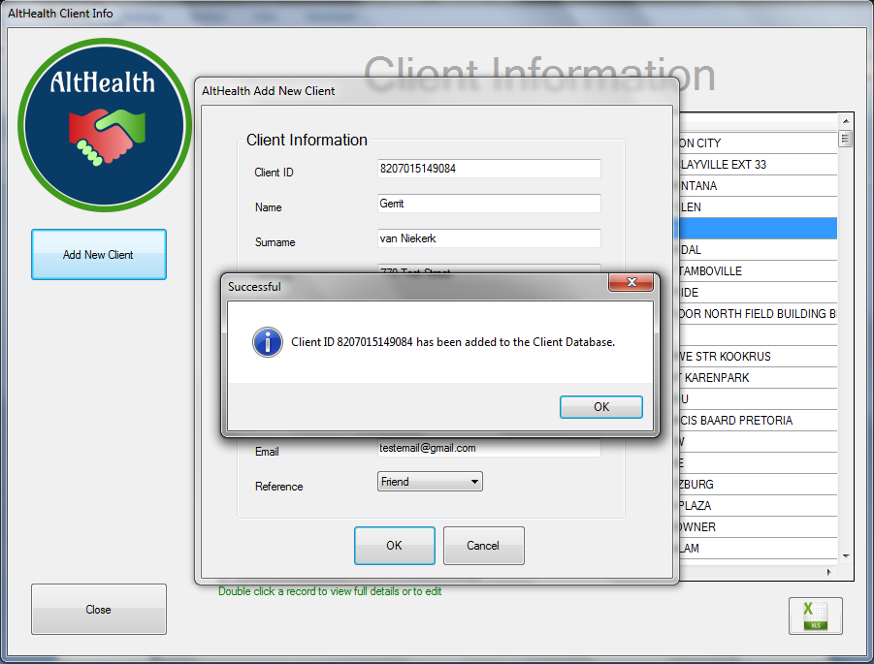

## 

## Client Information – Export Client Information

To Export a full list of all clients, click on the Export Button



Select the Folder where you want to save the Client Information Report.

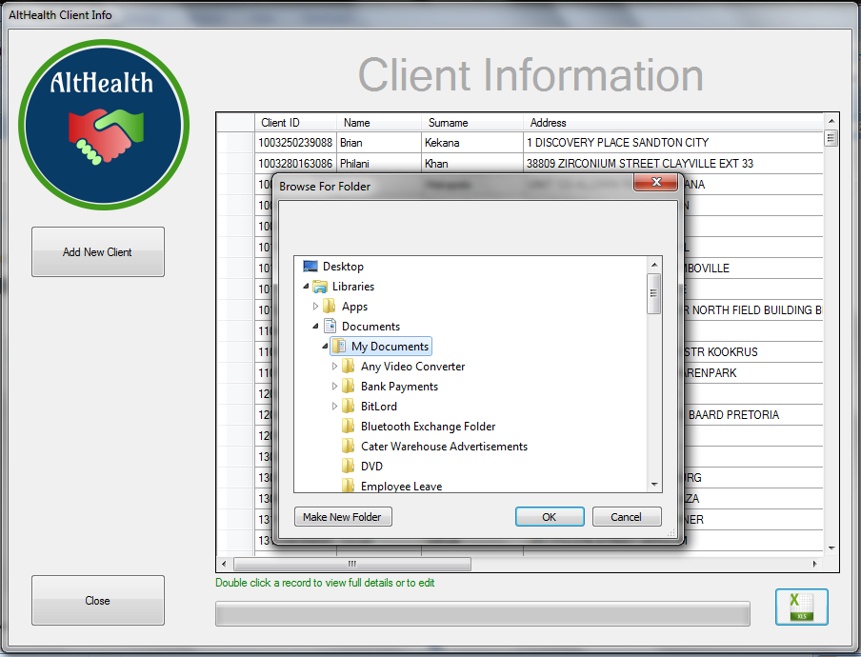

The Progress bar will inform the user of the report extract progress

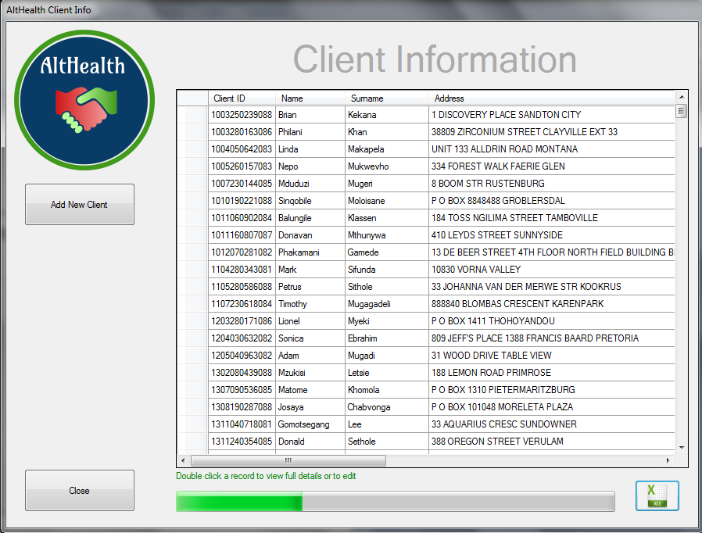

Once the Report extract is finished, a message will be displayed.

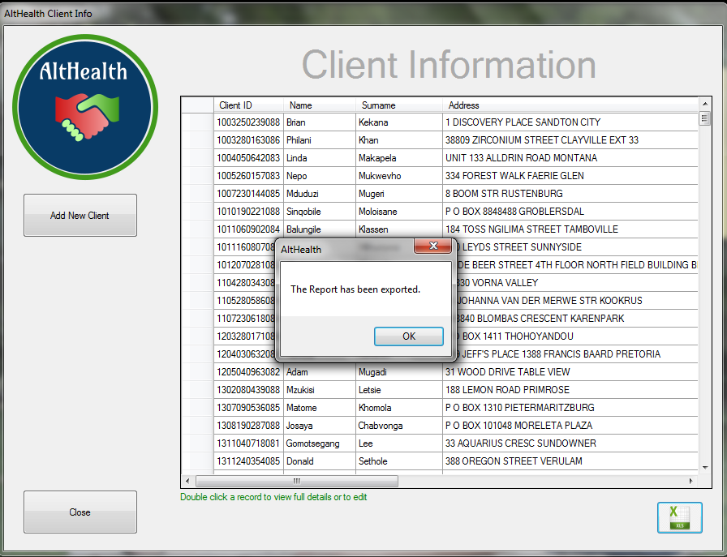

The Report is saved under the selected folder with a date and time stamp

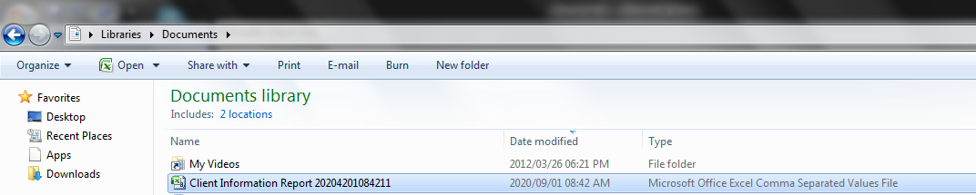

## 

## Supplier Information

## Supplier Information – View Supplier Details

Click Supplier Informtion

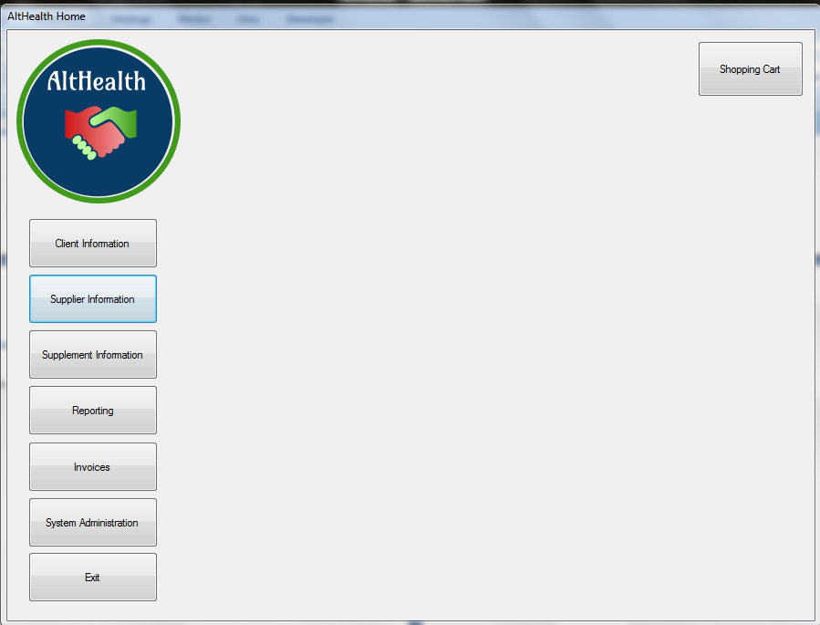

A List with all suppliers in the database will be displayed.

Use the scroll bar on the right to browse through the list.

The headings in the table can be used to sort the data

To view a particular supplier, double click the record

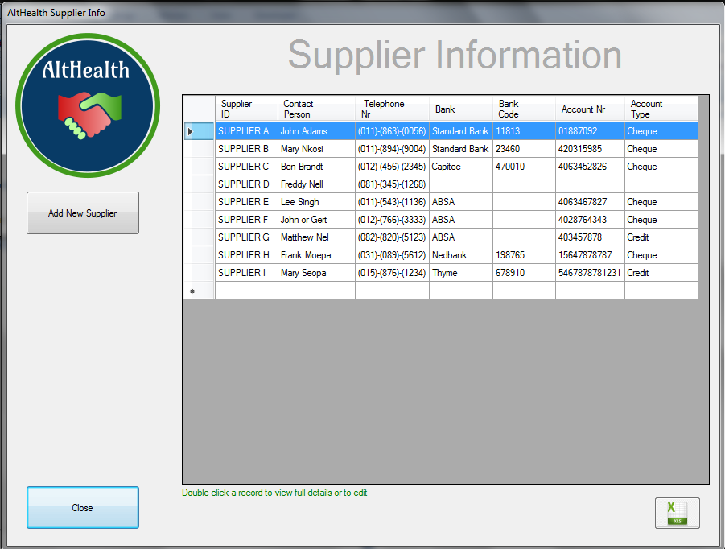

The supplier information will be displayed

To move back to the Supplier Information Screen, click the Close Button

To Edit the record, Click on the Edit Button

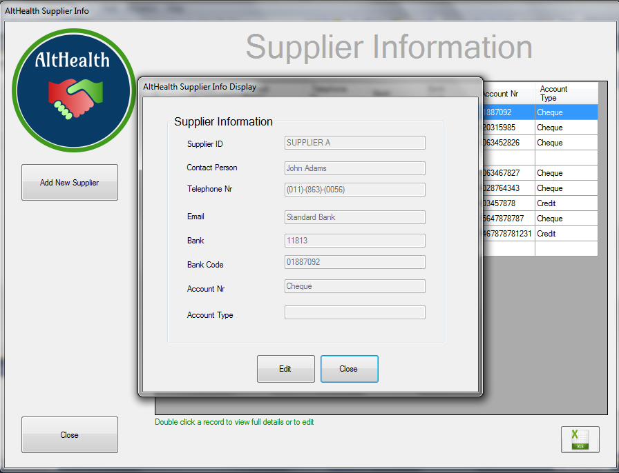

## Supplier Information – Edit Supplier Details

To Edit a Supplier, select the Supplier from the list and double click. Then click the edit button

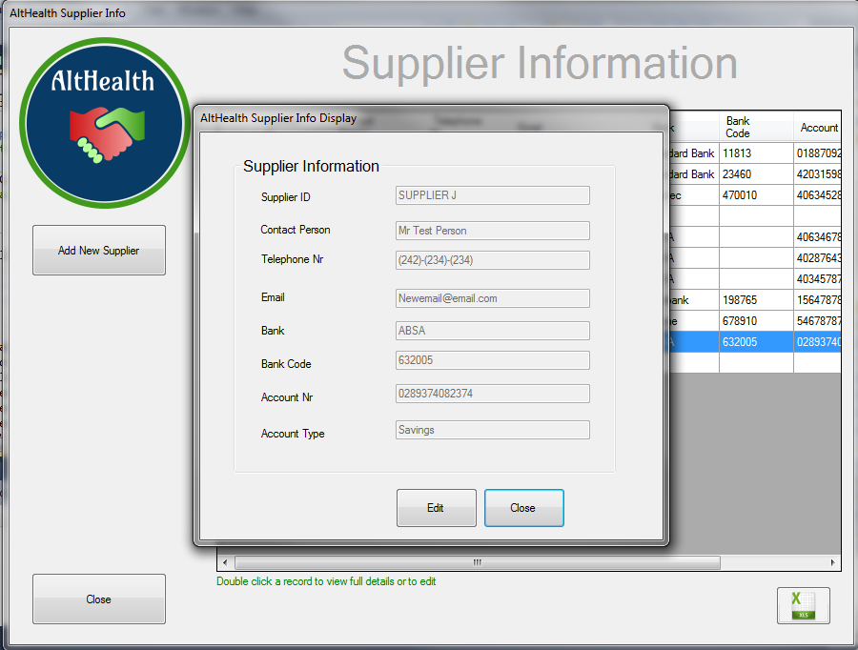

Certain fields will now be editable

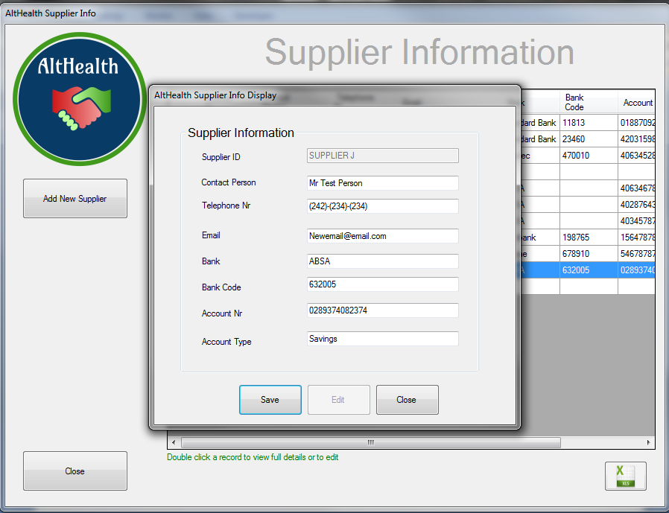

Make the needed changes and click on Save

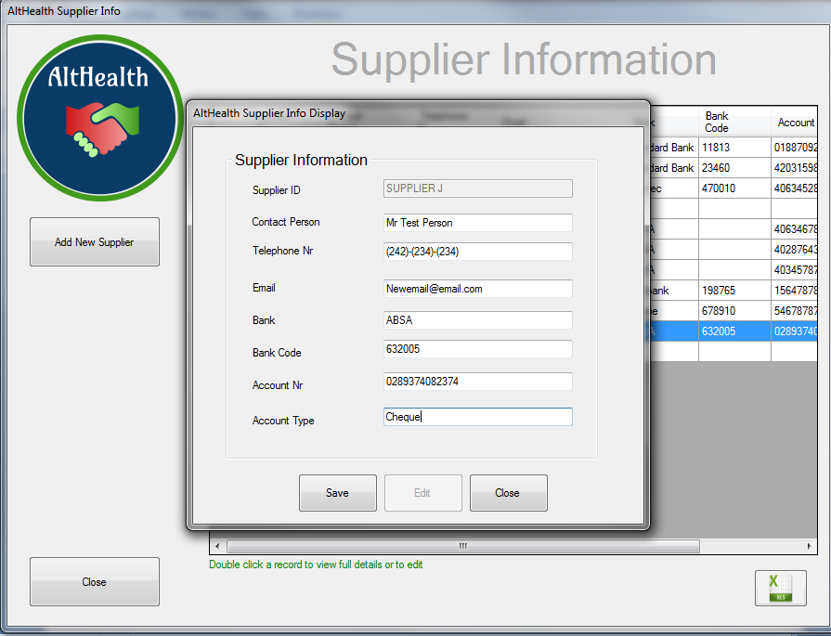

Confirm the changes

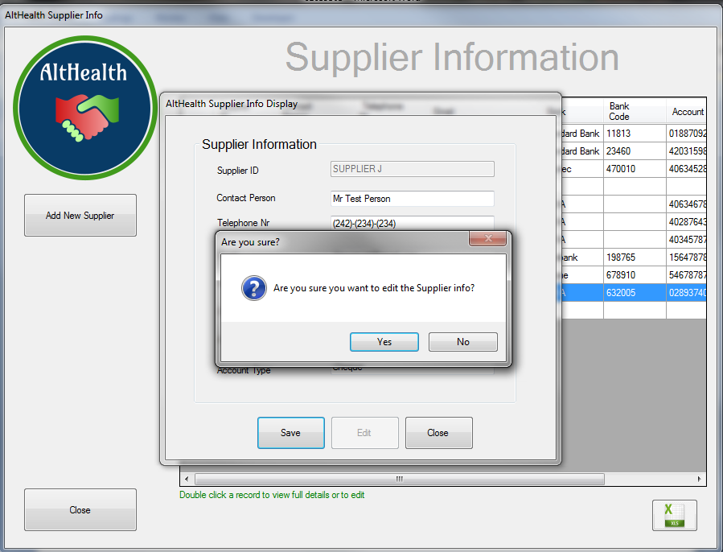

Wait for the confirmation message

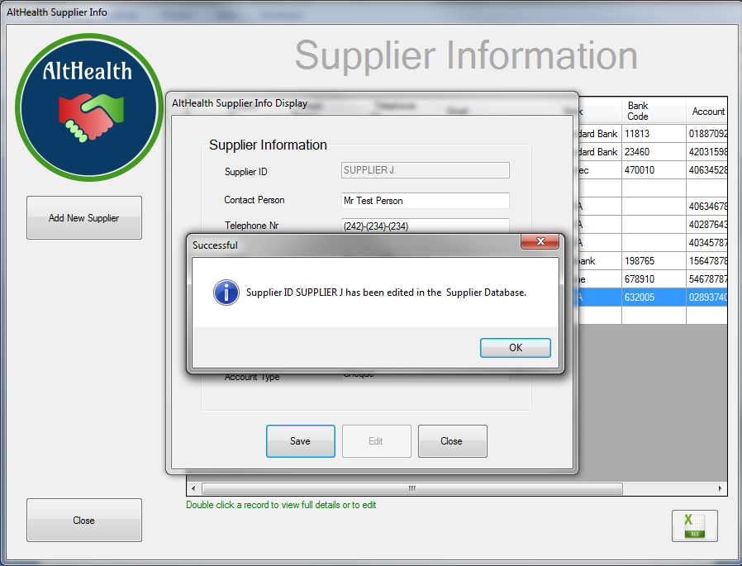

Review the changes in the table

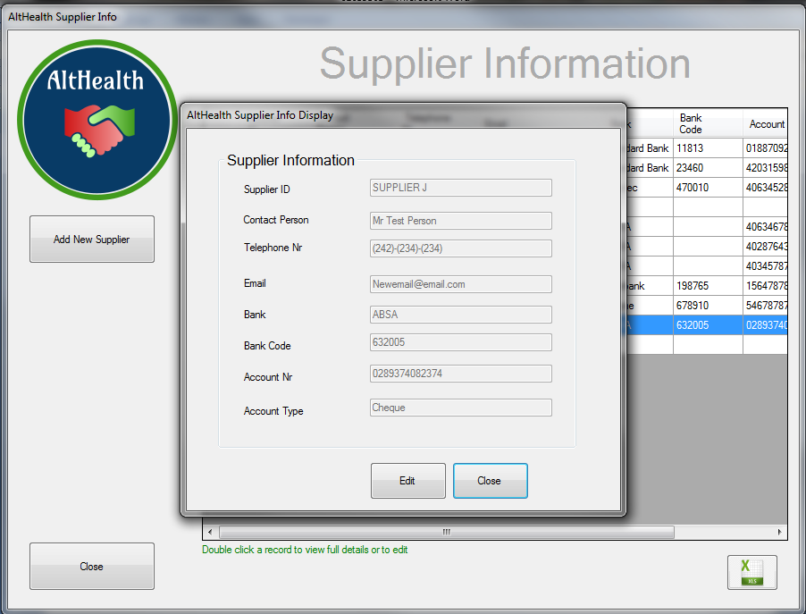

## Supplier Information – Add New Supplier Details

To add a new supplier, click on the Add New Supplier Button



To Save the Supplier Record to the Database, fill in all Mandatory Fields and Click the OK Button

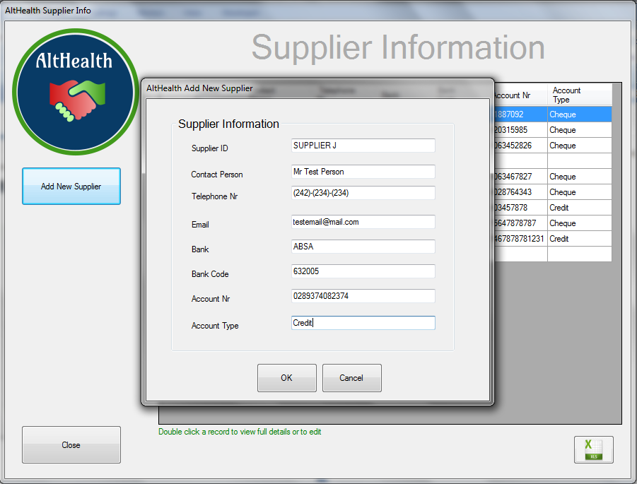

Confirm the addition by Clicking the YES Button

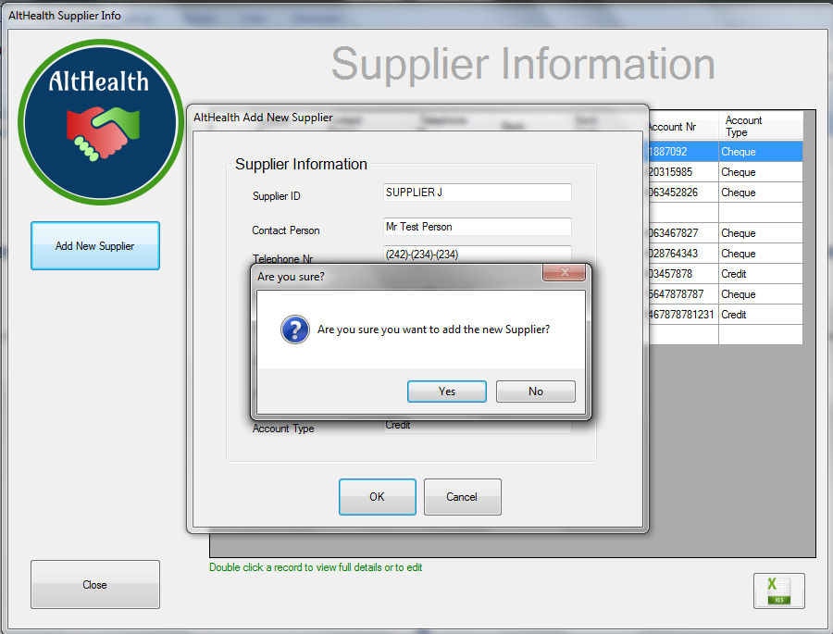

The confirmation message is displayed informing the user that the supplier has been added

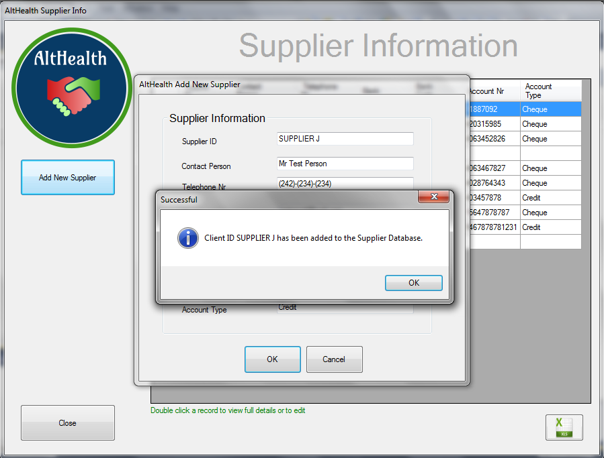

## Supplier Information – Export Supplier Information

To Export a full list of all suppliers, click on the Export Button

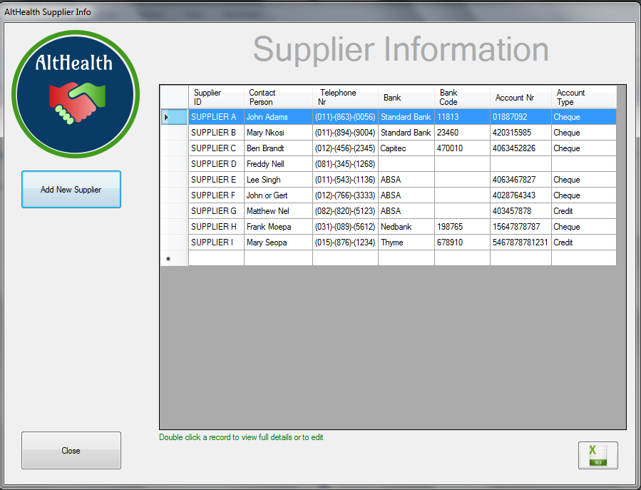

Select the Folder where you want to save the Supplier Information Report.

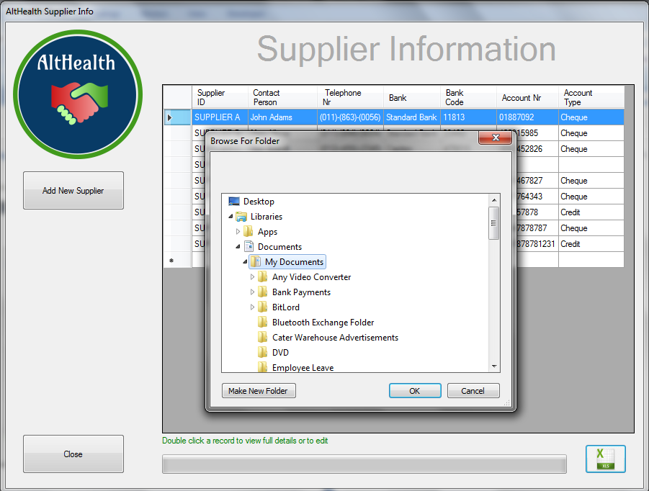

The Progress bar will inform the user of the report extract progress

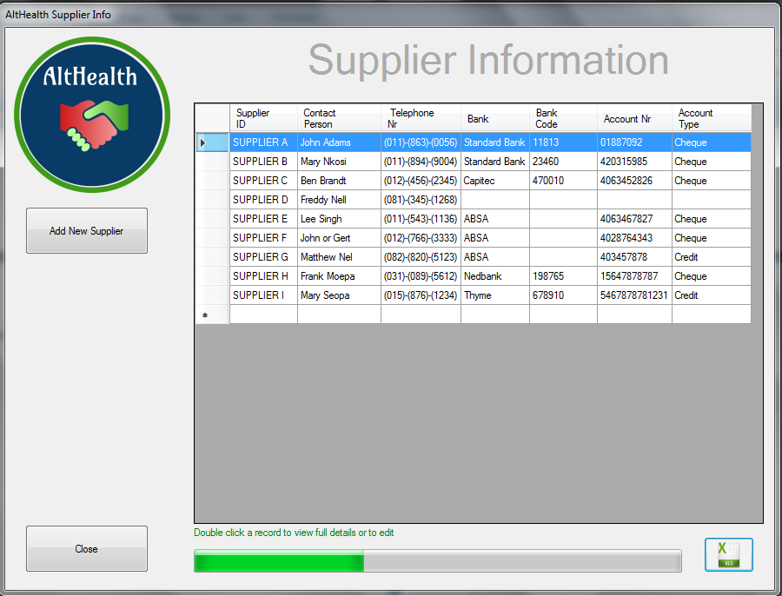

Once the Report extract is finished, a message will be displayed.

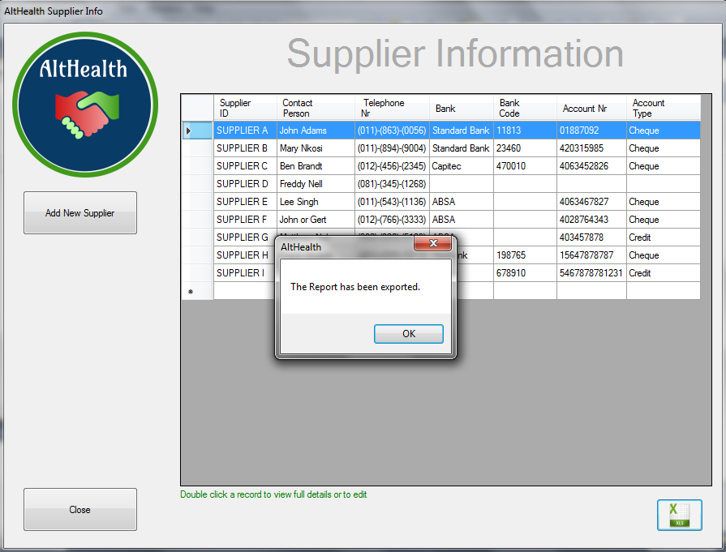

The Report is saved under the selected folder with a date and time stamp

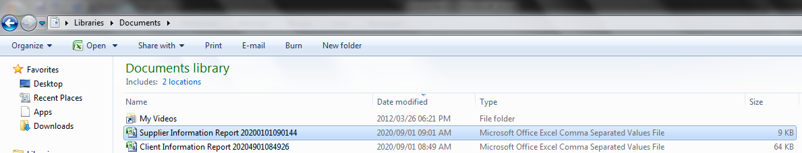

## Supplement Information

## Supplement Information – View Supplement Details

Click Supplement Informtion

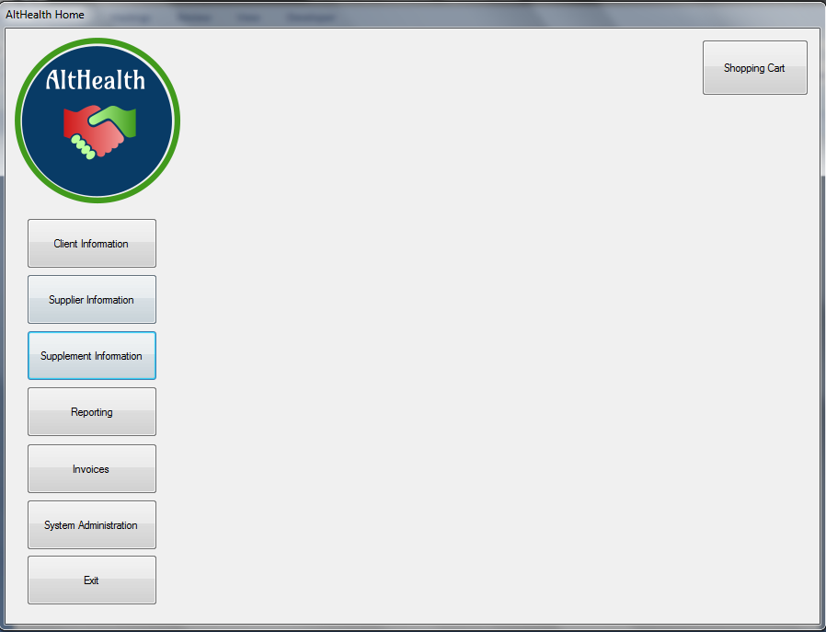

A List with all Supplements in the database will be displayed.

Use the scroll bar on the right to browse through the list.

The headings in the table can be used to sort the data

To view a particular Supplement, double click the record

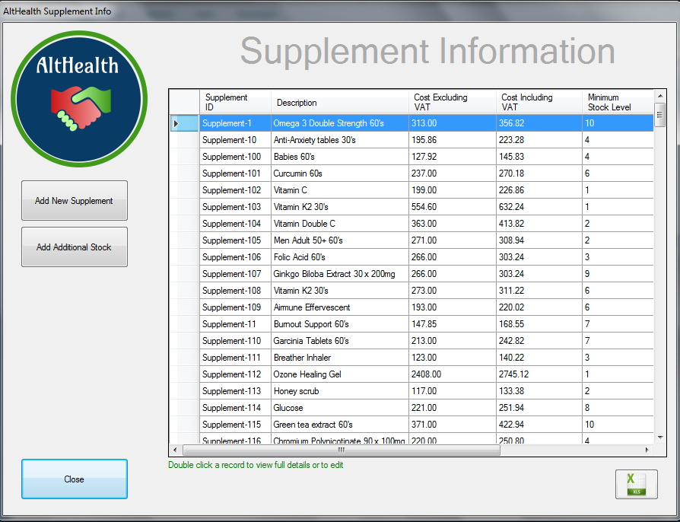

The Supplement information will be displayed

To move back to the Supplement Information Screen, click the Close Button

To Edit the record, Click on the Edit Button

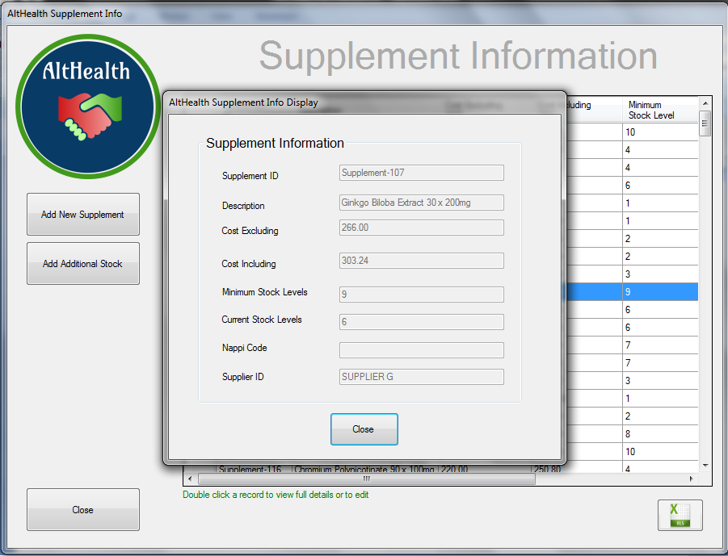

## 

## Supplement Information – Edit Supplement Details

To Edit a Supplement or to add additional Stock, select the supplement from the list by double clicking and click the Edit Button

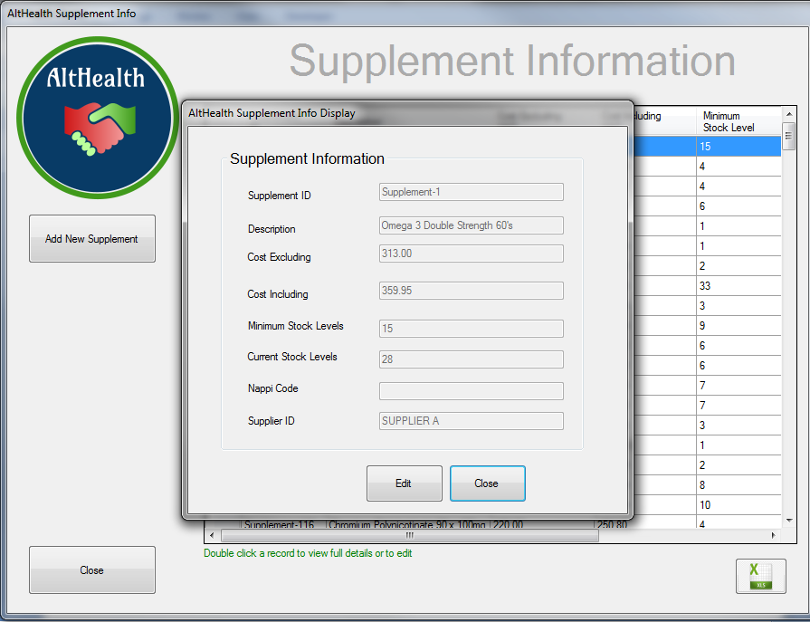

Certain fields are now availble to Edit

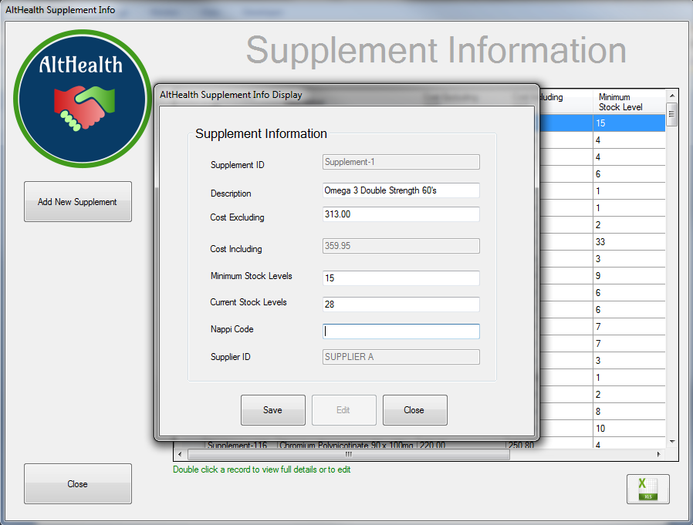

Make the needed changes and click the Save button

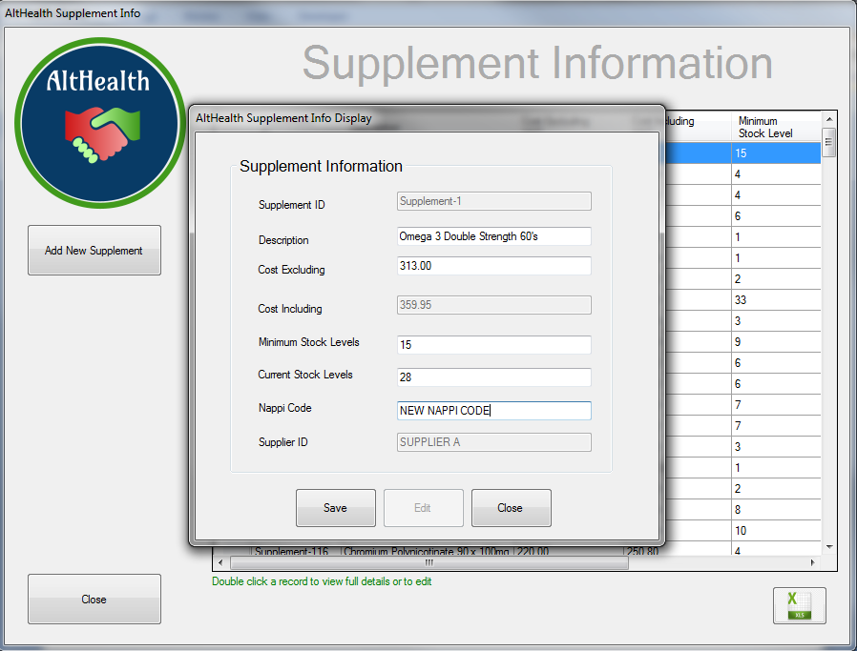

Confirm the Chaanges

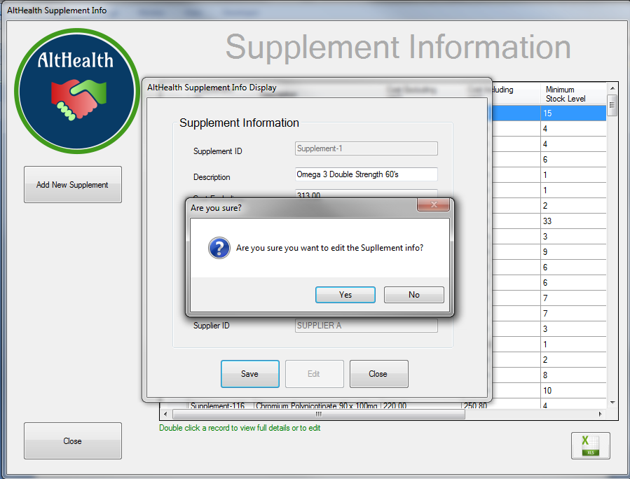

Wait for the confirmation message

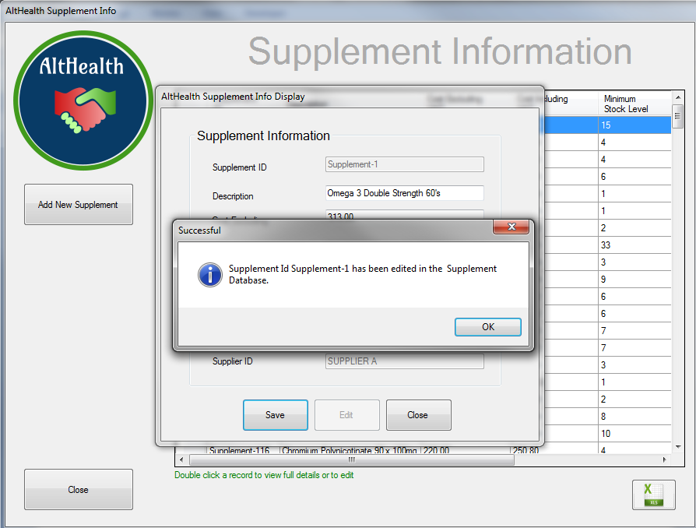

Review the changes in the list

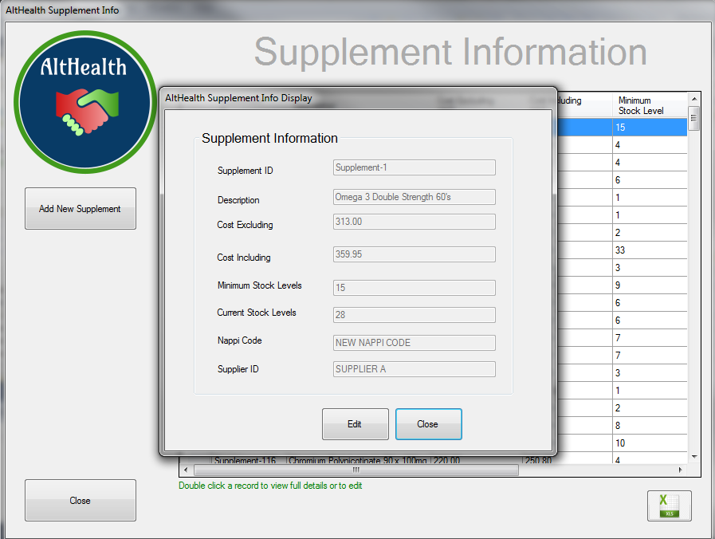

## Supplement Information – Add New Supplement Details

To add a new Supplement, click on the Add New Supplement Button

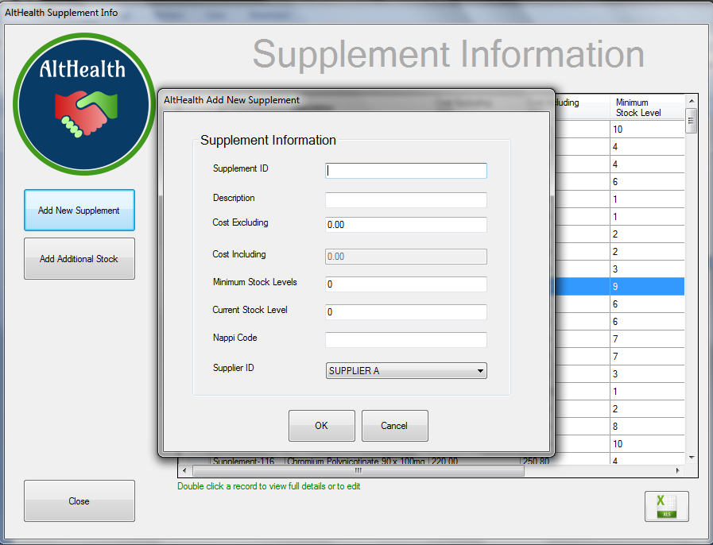

To Save the Supplement Record to the Database, fill in all Mandatory Fields and Click the OK Button

Cost Including Vat will automatically be calculated

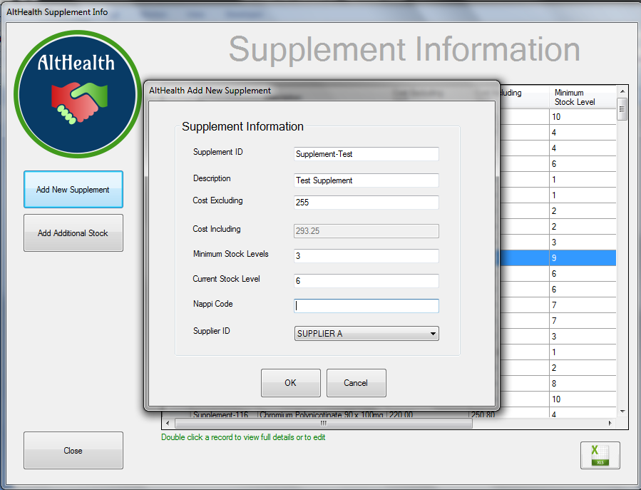

Confirm the addition by Clicking the YES Button

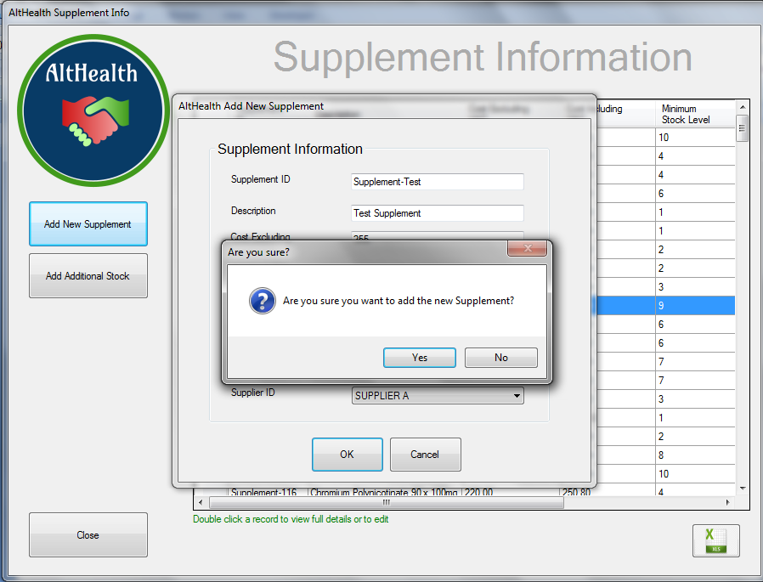 The confirmation message is displayed informing the user that the Supplement has been added

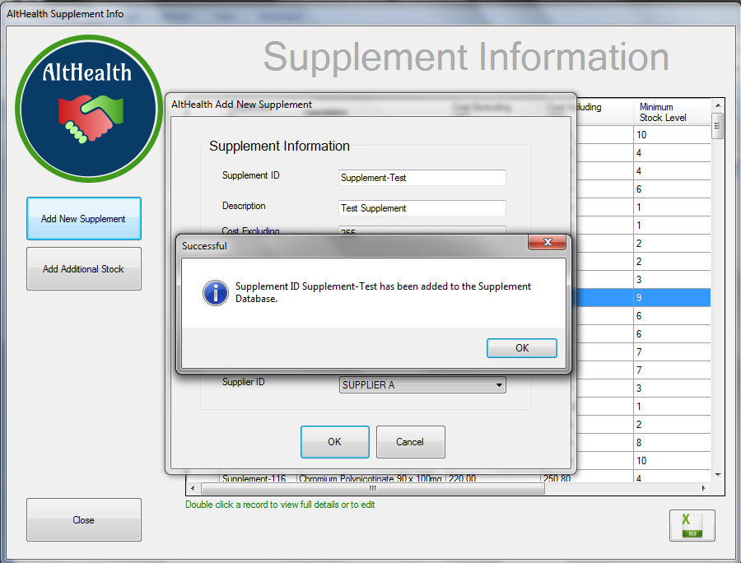

## Supplement Information – Export Supplement Information

To Export a full list of all Supplementa, click on the Export Button

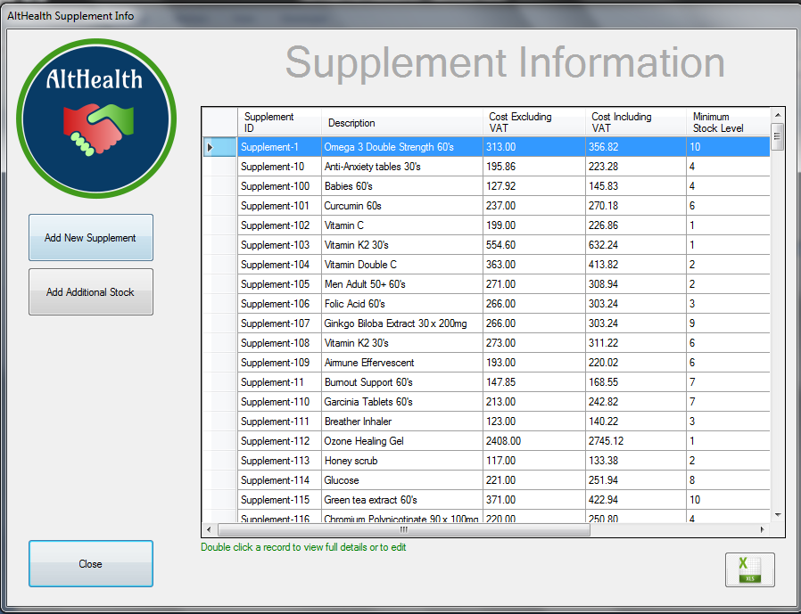

Select the Folder where you want to save the Supplement Information Report.

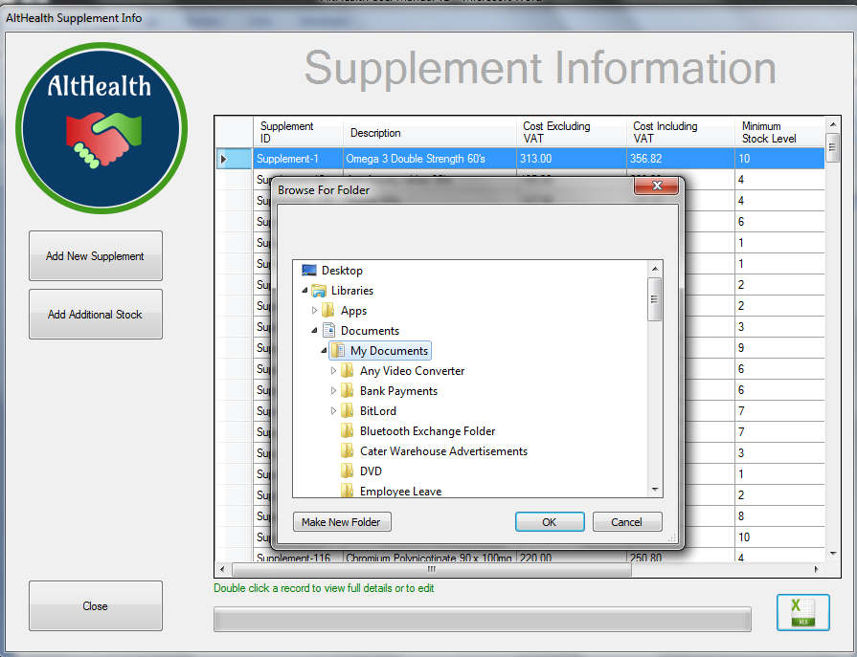

The Progress bar will inform the user of the report extract progress

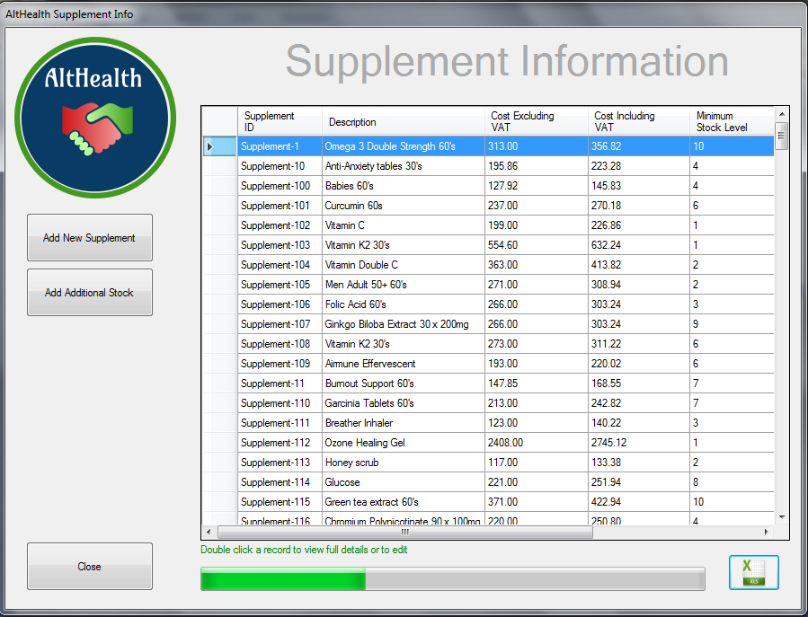

Once the Report extract is finished, a message will be displayed.

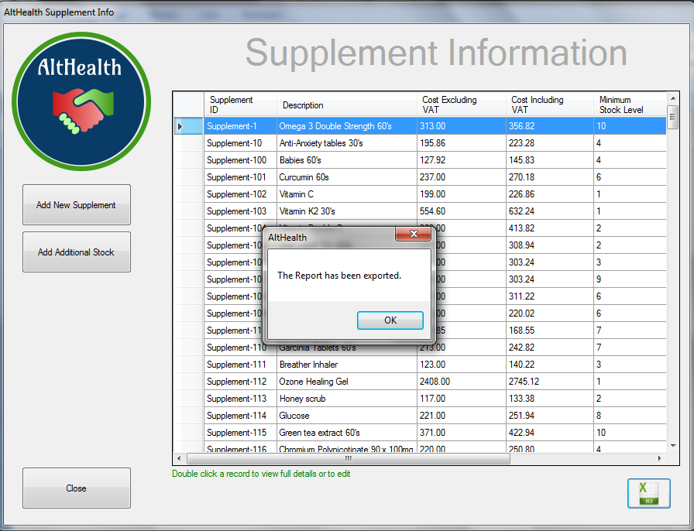

The Report is saved under the selected folder with a date and time stamp

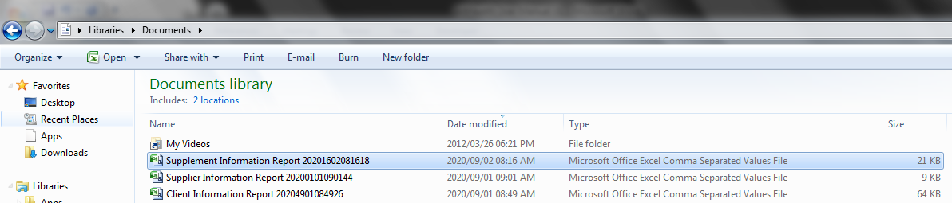

## 

## Reporting

To view Reports, click on the Reporting Button

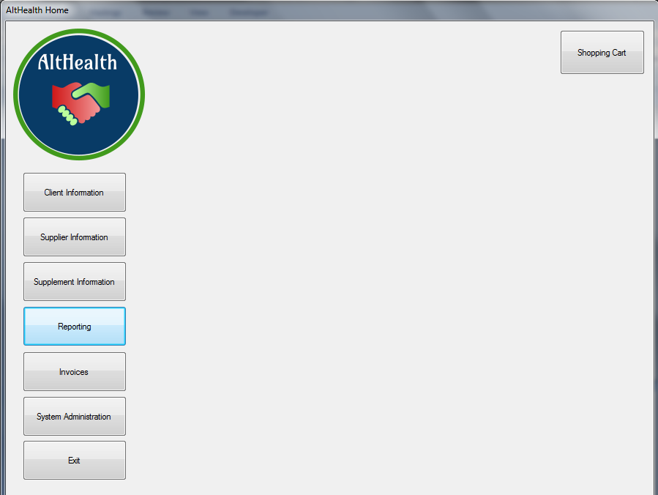

Click on the report you need to view

Click the Close button to move back to the home screen

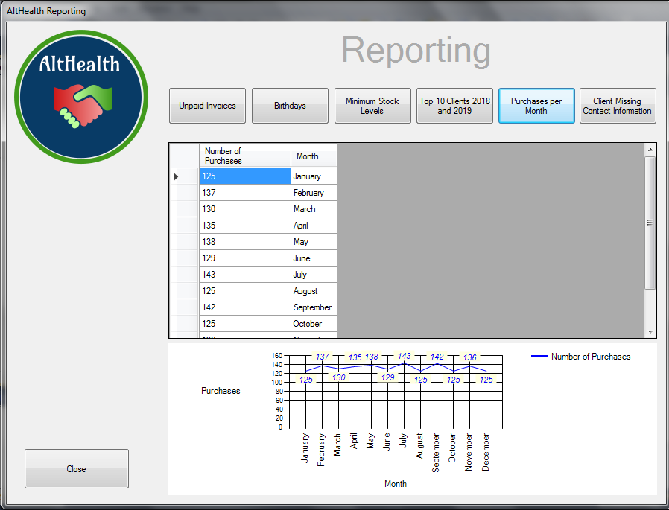

## Invoices

## Creating an Invoice – Shopping Cart

Click on the Shopping Cart



The invoice Nr and date will automatically generate

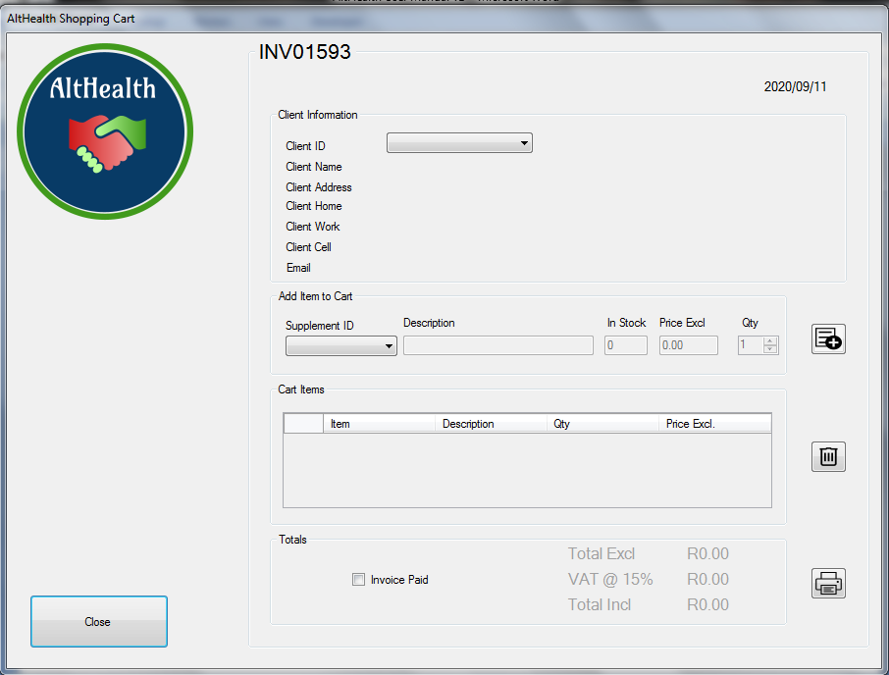

Select the Client ID

Once selected, the client information will automtically pull through

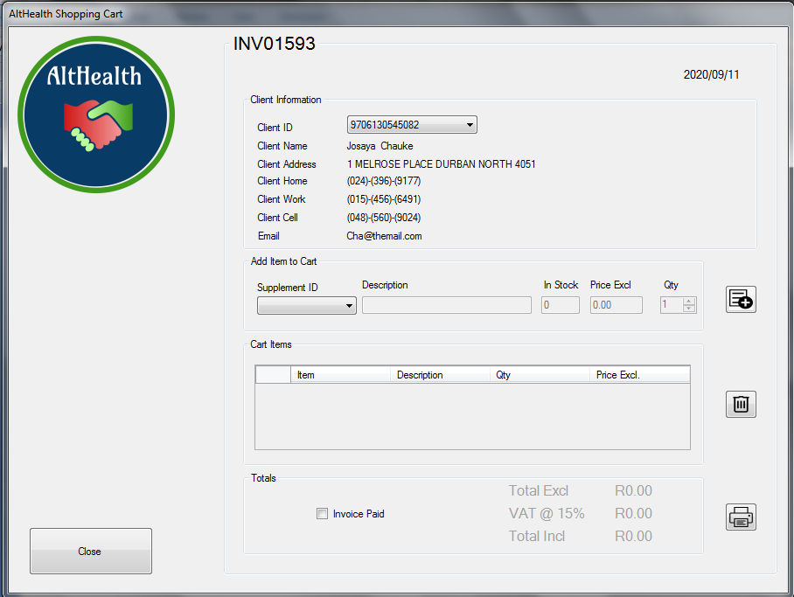

Add items to the cart by selecting the Supplement ID and the Qty, then click the dd button

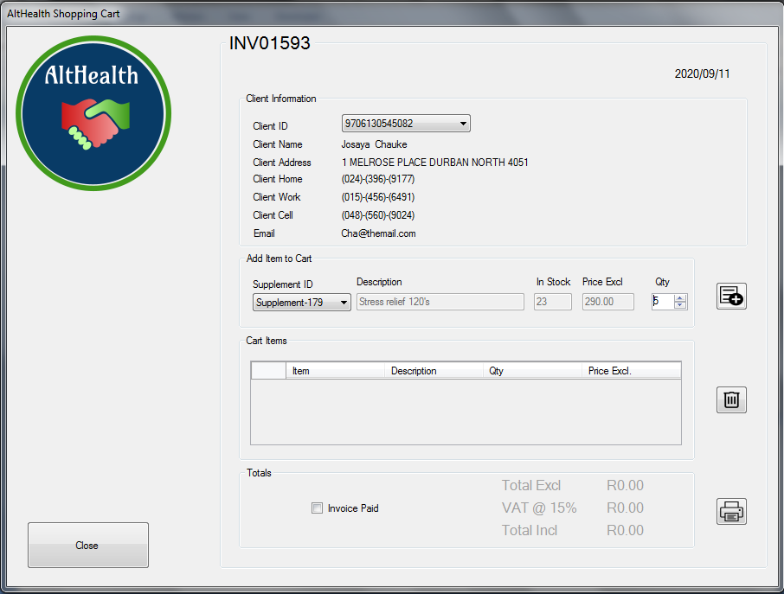

The Added items will display in the Cart Items Section

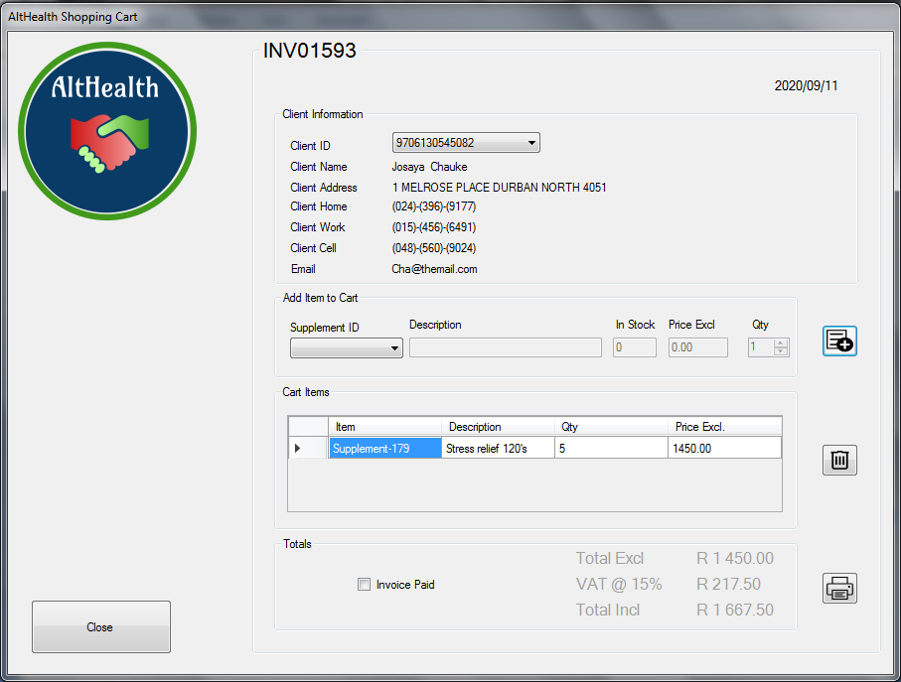

Continue to Add Items to the Cart.

The totals and Subtotals will automatically calculate

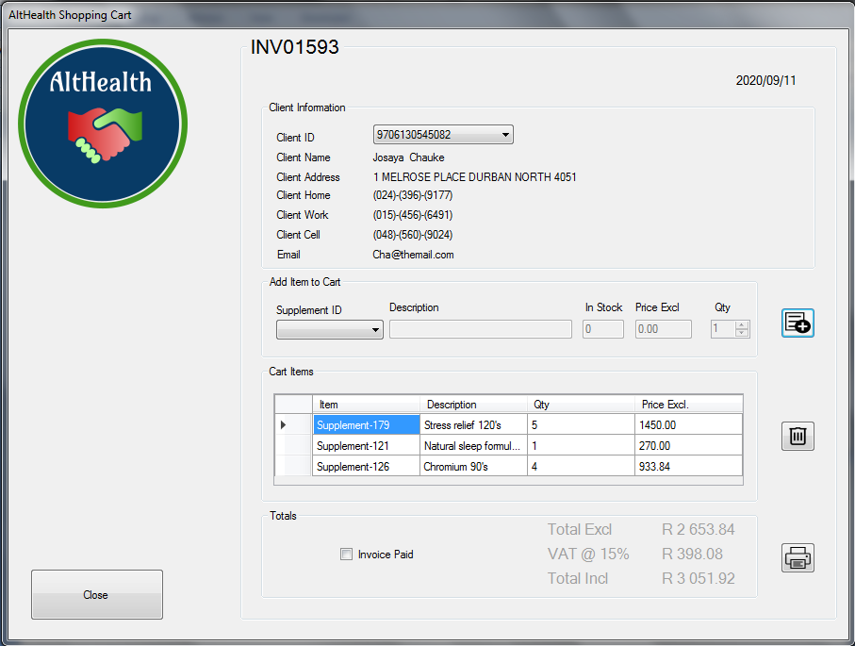

In case you need to remove an item, Click on the Item Line and then on the Delete Button. Confirm the removal. The Items will be deleted and the totals will be recalculted

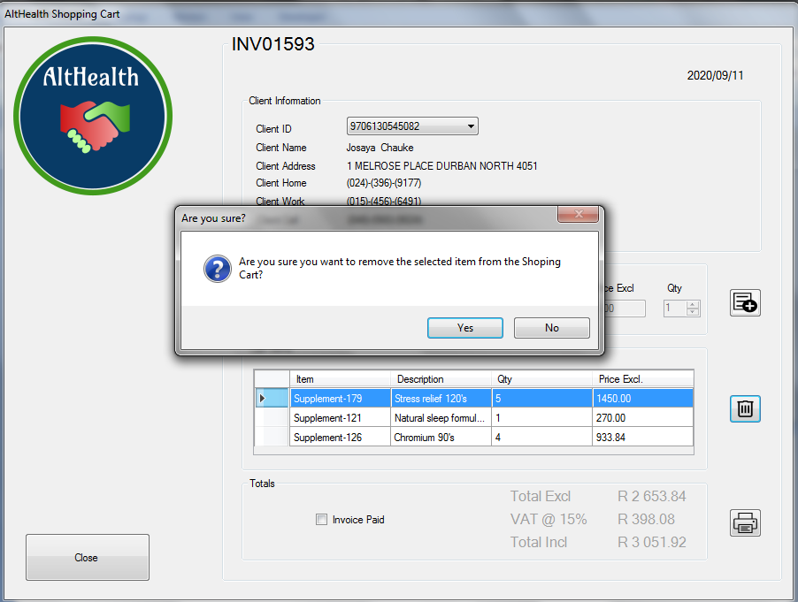

If the Customer paid immediately, you can tick the “Invoice Paid” Box. If not, then you cn leave it unticked

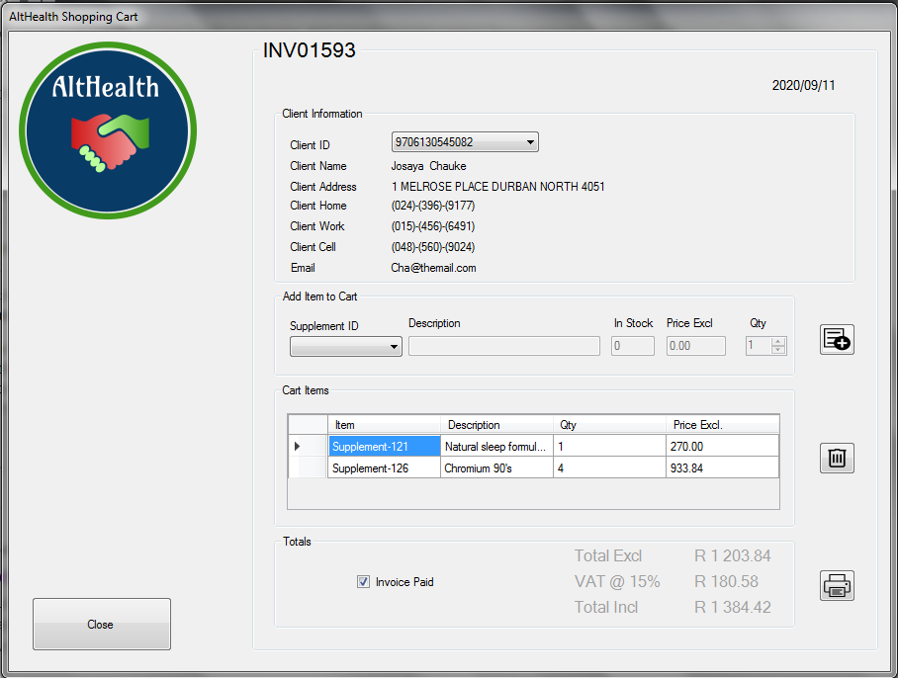

To Generate the Invoice, click the Print Button and confirm the selection

The Print Button will generate an Invoice, Stored it in the Documents Folder and Email it to the client if there is an email address

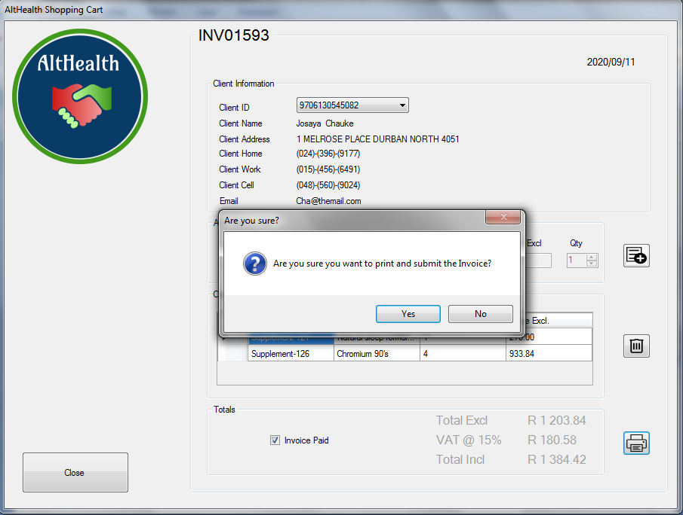

A Message will be displayed to say that the invoice waas generated. Click the OK button and wait for the confirmation of the Email

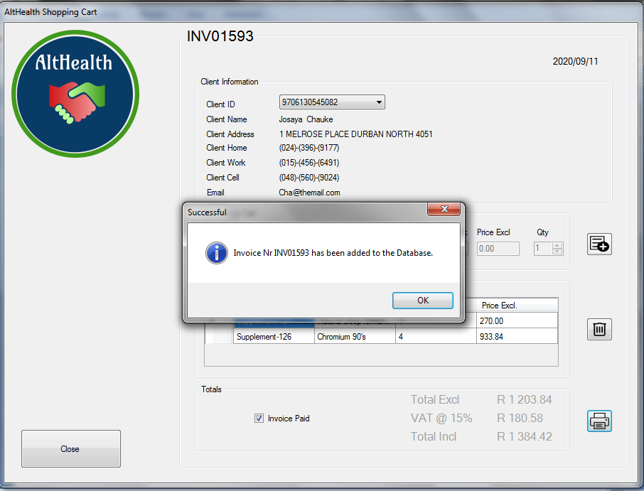

All Generated Invoice can be found in the invoices Folder

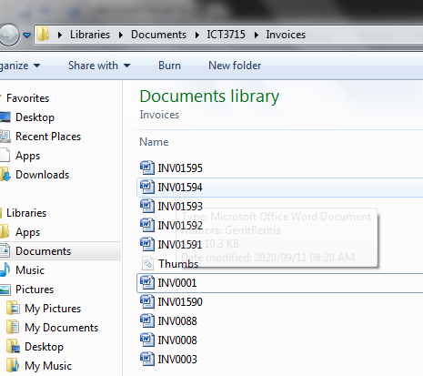

## Search for Existing Invoices

To search for an invoice that has already been generated, click on the Invoice Button

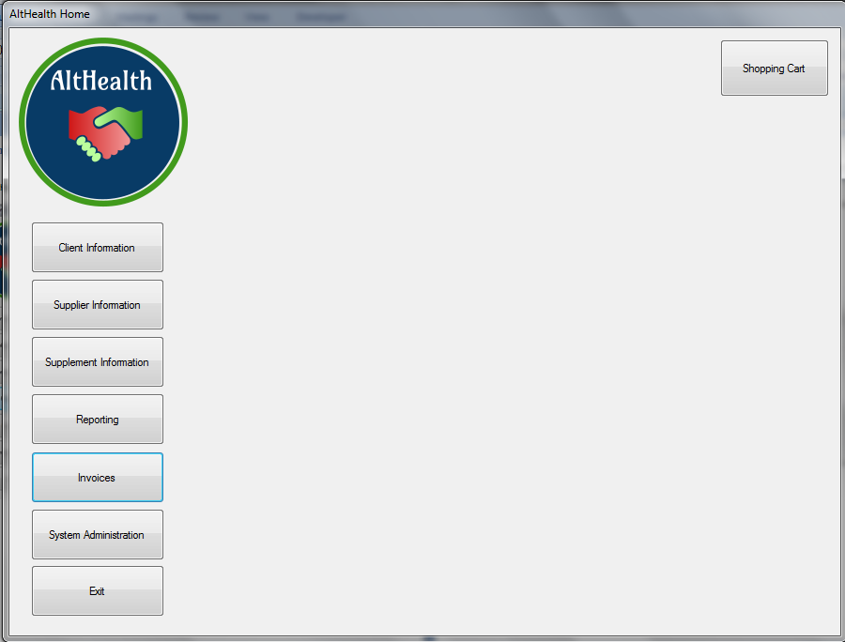

Enter the Invoice nr and press enter

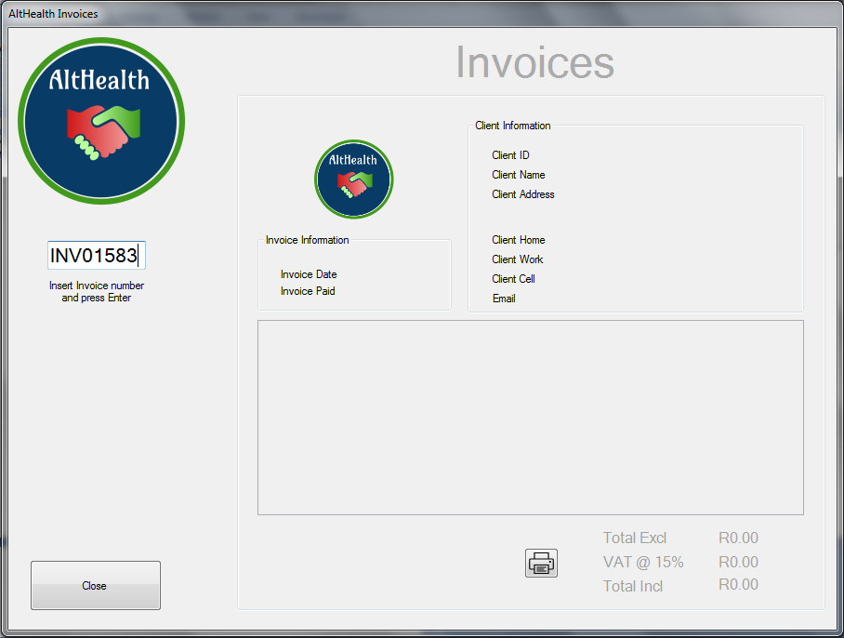

The invoice data will be extracted and displayed in the fields

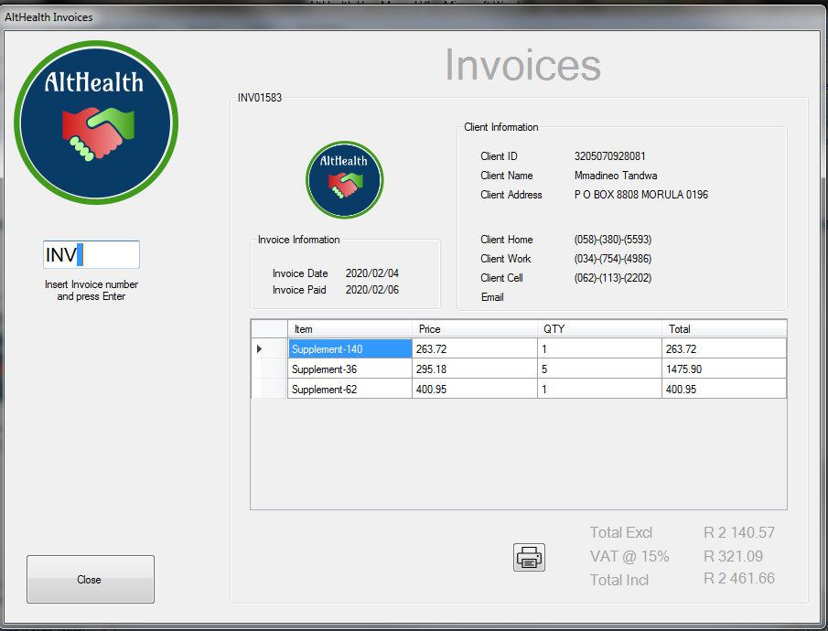

To Reprint or generate the invoice, click on the Print Button and confirm.

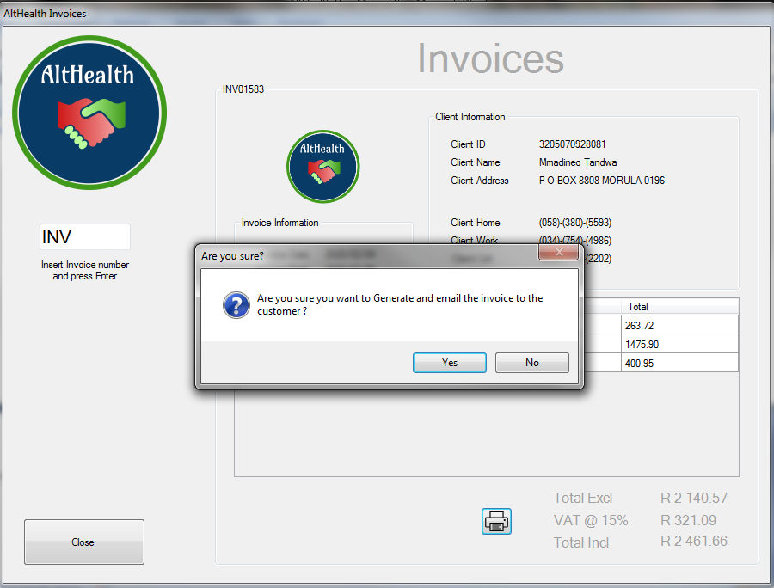

The invoice will be generated and saved in the documents folder. If the invoice is already existing, it will be replaced with a new version

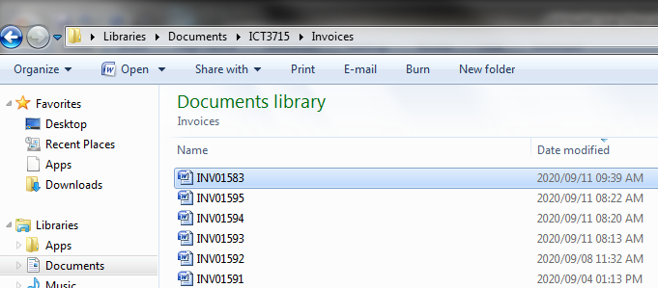

## Restore data to the latest version

Select System Administration



Select “Recover Database”



## Confirm and wait for the confirmation message. The database will be restored to the latest version.





## Appendices

## Appendix A – Change Request Template

The following template is used by the client in case of any system changes or enhancements are needed.

## 

## AltHealth.exe Business Requirement Document

|  |
| --- |
| Date: Request Date |
| Short Description: Short Description of change |
| Full Description: Full Description of change including all workflows. Here, as much information as possible is needed in order for the developer to fully understand the requirement |
| Screenshots: Add any screenshots or mock up of the change requested |
| Affected Modules: List all affected modules within the application where the change will have an impact on. |
| Requester: Requester name |
| Signature: Requester Signature |

## Appendix B – Information Flow Diagram

The below diagram gives the client the overview of the technical data flow for the application

